1. [Engagement Tools Tutorial in Burp suite](https://www.hackingarticles.in/engagement-tools-tutorial-burp-suite/)
2. [Payload Processing Rule in Burp suite (Part2)](https://www.hackingarticles.in/payload-processing-rule-burp-suite-part-2/)
3. [Payload Processing Rule in Burp suite (Part1)](https://www.hackingarticles.in/payload-processing-rule-burp-suite-part-1/)
4. [Beginners Guide to Burpsuite Payloads (Part2)](https://www.hackingarticles.in/beginners-guide-burpsuite-payloads-part-2/)
5. [Beginners Guide to Burpsuite Payloads (Part1)](https://www.hackingarticles.in/beginners-guide-burpsuite-payloads-part-1/)
6. [Burpsuite Encoder & Decoder Tutorial](https://www.hackingarticles.in/burpsuite-encoder-decoder-tutorial/)
7. [Burp Suite for Pentester: Active Scan++](https://www.hackingarticles.in/burp-suite-for-pentester-active-scan/)
8. [Burp Suite for Pentester: Software Vulnerability Scanner](https://www.hackingarticles.in/burp-suite-for-pentester-software-vulnerability-scanner/)
9. [Burp Suite for Pentester: Burp’s Project Management](https://www.hackingarticles.in/burp-suite-for-pentester-burps-project-management/)

# Engagement Tools Tutorial in Burp suite

[February 6, 2018](https://www.hackingarticles.in/engagement-tools-tutorial-burp-suite/) By [Raj Chandel](https://www.hackingarticles.in/author/raaj/)

Today we are going to discuss the Importance of **Engagement tools** which is a Pro-only feature of Burp Suite. It is mainly used in information gathering and hence the analysis of any web application testing.

Its four important utilities are the following:

* Find References
* Discover Content
* Schedule Task
* Generate CSRF POC

### ****Find References****

This function can be used to search all Burp suite tools for HTTP responses that link to a particular item. To make use of this function, select an HTTP request anywhere in Burp suite, or any part of the site map, and choose “Find references” in “Engagement tools” in the context menu which can be seen clicking Action Tab within Burp suite.

The result window of the search shows responses (from all Burp tools) that are linked to the selected item. Whenever we view an individual search result, the response will be automatically highlighted to show where the linking reference is occurring.

This function treats the original URL as a Prefix whenever we search for links, so if you select a host, you will find all references related to the host and if you select a folder, you will find all references to items inside that folder.

First, we have intercepted the request of the **Vulnweb.com** which is a **demo lab** available over the internet which can be used for testing attacks. Then click on enter after writing the URL of the Vulnerable Web in your browser, then the burp suite will capture the request of the web page in the intercept tab.

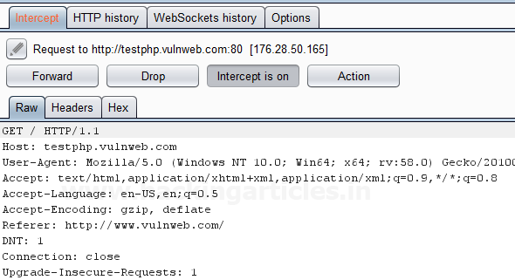

Then**click** on **Action Tab**, after that select the **Engagement tools**then click on **Find References**. This will open a result window which will show all the references related to the **URL** whose request has been captured which is the**Vulnerable Web**as shown in the image.

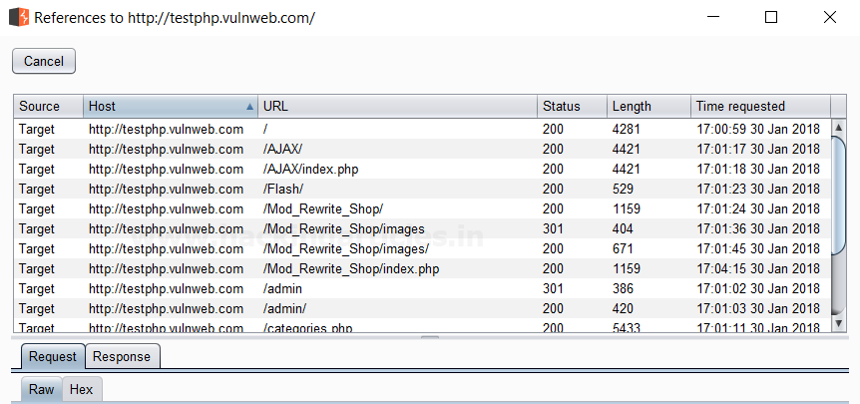

### ****Discover Content****

This function is used to discover contents and functionality which are not linked with visible content that you can browse or spider.

There are various techniques that the burp suite uses to discover content, which includes name guessing, web spidering, and extrapolation from naming conventions observed within the use of an application.

**Control**

This tab shows you the current status of the session. The **toggle button** represents whether the session is running or not, and it also allows you to pause and restart the session.

The following information is displayed about the progress of the discovery session:

* Number of requests made
* Number of bytes transferred in server responses
* Number of network errors
* Number of discovery tasks queued
* Number of spider requests queued
* Number of responses queued for analysis

**Target**

This option allows you to define or state the start directory of the content discovery session, and whether the files or directories should be targeted. The options that are available are as follows:

* **Start directory** – This is the location where Burp suite is used to look for content. The items within this path and sub-directories are requested during the session.
* **Discover** – This option can be used to determine whether the session will look for files or directories or both.

### ****Site Map****

The discovery session uses their own site map, showing all of the content which has been discovered within the defined scope. If you have configured your Burp suite to do so, newly discovered items can be added to Burp suite’s main site map.

First, we have intercepted the request of the **Vulnweb.com** which is a **demo lab** available over the internet which can be used for testing attacks. Then click on enter after writing the URL of the Vulnerable Web in your browser, then the burp suite will capture the request of the web page in the intercept tab.



Then **click**on**Action Tab** within the Burp suite, after that select the **Engagement tools**then click on **Content Discovery**. This will open a result window which will show the discovery session status and queued tasks which are related to the **URL** whose request has been captured which is the**Vulnerable Web**as shown in the image.

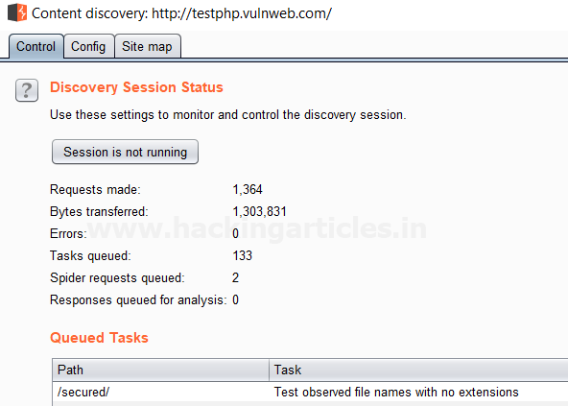

### ****Schedule Task****

This function can be used to automatically start and stop certain tasks at defined times and intervals. We can use the task scheduler to start and stop certain automated tasks while you are not working, and to save your work periodically or at a specific time.

To make use of this function, select an HTTP request anywhere in Burp suite, or any part of the target site map, and choose “Schedule task” within “Engagement tools” in the context menu which can be seen by clicking right within Burp suite.

The types of task that are available within this function are as follows:

* Scan from a URL
* Pause active scanning
* Resume active scanning
* Spider from a URL
* Pause spidering
* Resume spidering
* Save state

First, we have intercepted the request of the **vulnweb.com**which is a **demo lab** available over the internet which can be used for testing attacks. Then click on enter after writing the URL of the Vulnerable Web in your browser, then the burp suite will capture the request of the web page in the intercept tab.



Then **click** on Action Tab within the Burp suite, after that select the **Engagement tools**then click on **Schedule Task**. This will open a window of schedule task options where we have selected **Scan from a URL**option as shown in the image.

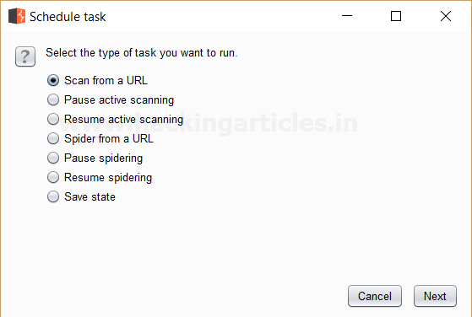

Then Click **Next** a window will open where we have to give the **URL**we want to scan its branches from the site map.

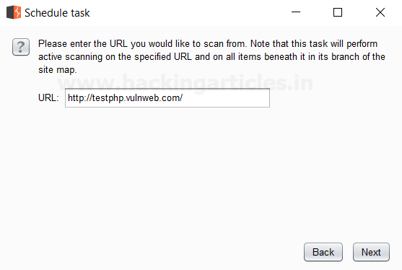

Then Click **Next** we see that the scanner tab of the burp suite is open which **scans** all the branches beneath the site map of the given **URL**which is seen in the **scan queue tab** as shown in the image which is related to the **URL** whose request has been captured which is the**Vulnerable Web**as shown in the image.

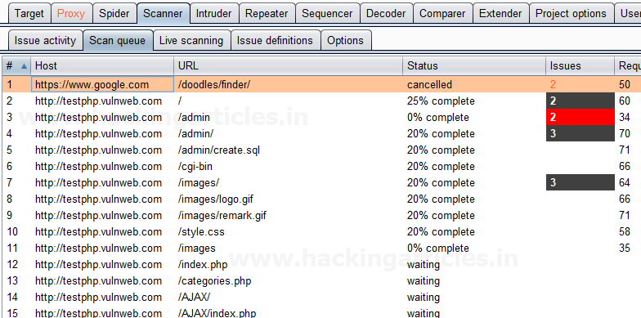

### ****Generate CSRF PoC****

This function can be used to generate a proof-of-concept (PoC) cross-site request forgery (CSRF) attack for any given request.

To access this function, select a URL or HTTP request anywhere in the Burp suite, and choose “Generate CSRF PoC” within “Engagement tools” in the context menu which can be seen by clicking right within Burp suite.

Let’s start!!

First, we have intercepted the request of the **CSRF (transfer amount)** option in the **Bwapp LAB**, where we have given an **Account Number**.

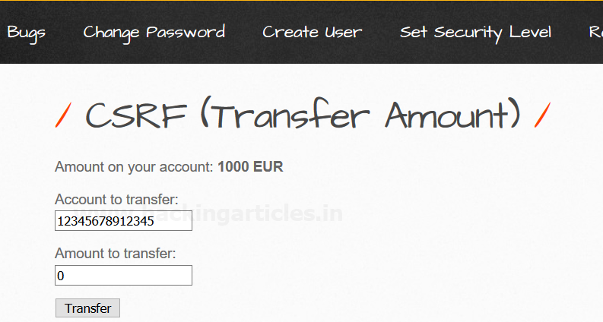

Then click on transfer, the burp suite will capture the request of the page in the intercept tab.

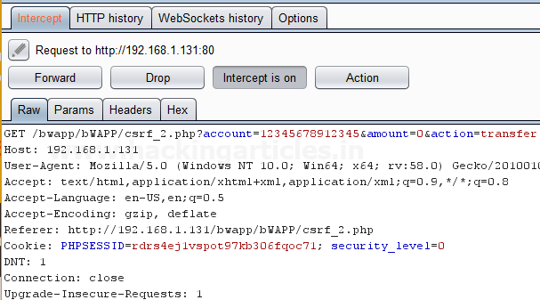

Then click on Action Tab within the Burp suite, after that select the **Engagement tools**then click on **Generate CSRF PoC**. This will open a window of the CSRF PoC where we made a change in **Account value** and **Amount value**in CSRF HTML code as shown in the image.

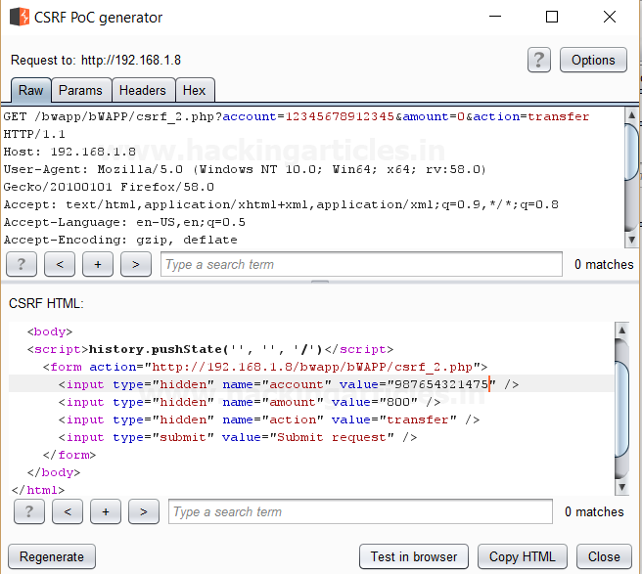

After making changes in the values click on **Test in Browser option** or**Copy HTML**this will open the window of Show response in the browser then click on **COPY**, and then paste it in the Browser and Press Enter as shown in the image.

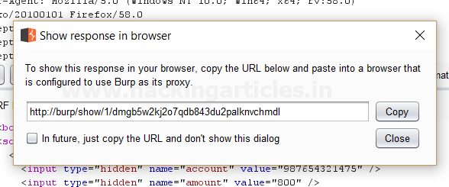

We see a Submit request Button is seen in the browser after that click on it.

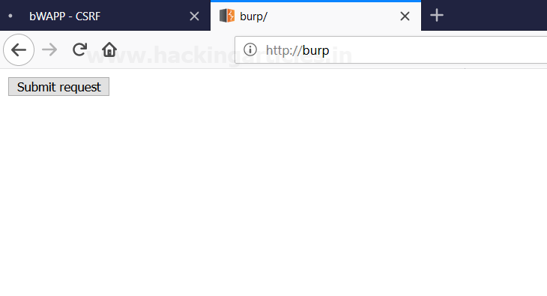

It appears to us that the amount is reduced as we have transferred the amount from the account by making changes in the CSRF HTML code as shown in the image.

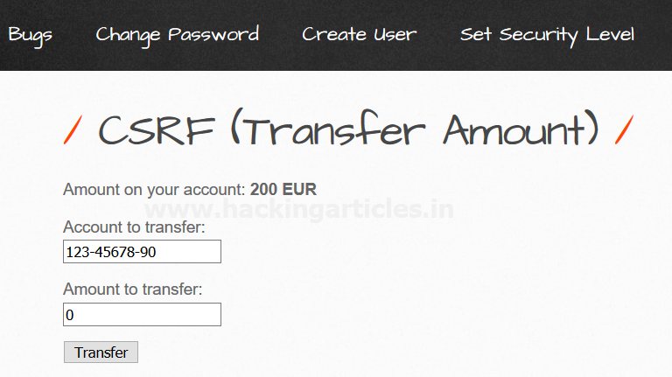

# Payload Processing Rule in Burp suite (Part 1)

[February 3, 2018](https://www.hackingarticles.in/payload-processing-rule-burp-suite-part-1/) By [Raj Chandel](https://www.hackingarticles.in/author/raaj/)

Today we are going to discuss the “Payload Processing” option of Burpsuite which is advanced functionality comes under **Intruder Tab** for making brute force attack.

### ****Payload Processing****

Payload Processing can be defined as when payloads are generated using **payload types,** they can be further **manipulated or filtered** using various **processing rules** and **payload encoding**.

**Payload Processing Rules**

These rules are defined to perform a various processing task on each payload before it is used. These rules are executed in a sequence, and they can be used to help debug any problem with the configuration. Payload processing rules are useful in situations where you need to generate different payloads, or where we want to wrap payloads within a wider structure or encoding scheme.

There are 12 types of payload processing rules available:

* **Add prefix**
* **Add suffix**
* **Match / Replace**
* **Substring**
* **Reverse substring**
* **Modify case**
* **Encode**
* **Decode**
* **Hash**
* **Add raw payload**
* **Skip if matches regex**
* **Invoke Burp extension**

**Let’s start!!**

### ****Add Prefix****

This processing rule adds up a prefix before the payload.

First, we have intercepted the request of the login page in the **Bwapp LAB**, where we have given default username and wrong password. Then click on login, the burp suite will capture the request of the login page in the intercept tab.

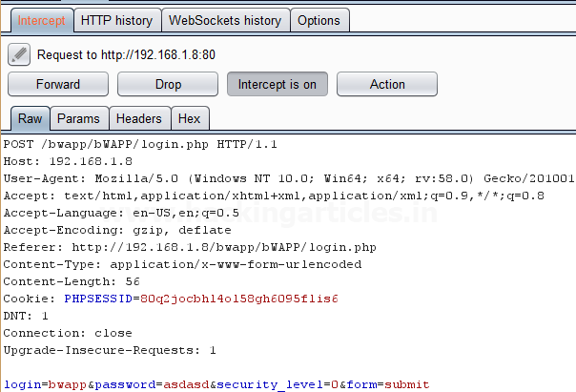

Send the captured request to the**Intruder**by clicking on the Action Tab and follow given below step. Now open the **Intruder tab**then select **Positions tab** and you can observe the highlighted password and follow the given below step for selecting payload position.

* Press on the **Clear button** given at right of the window frame.
* Now we will select the fields where we want to attack and i.e. the password filed and click on **Add button.**
* Choose the **Attack type** as **a sniper**
* In the given below image, we have selected a password that means we will need one dictionary files for a password.

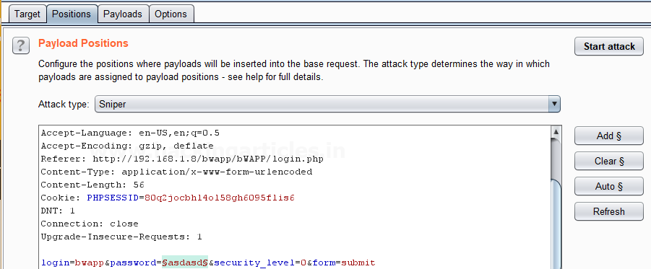

Now click on **payloads option** after selecting payload position. Then select the **Payload type** as **Simple list,** where we have added a dictionary by clicking on **Load** button. We can either load the dictionary or we can manually add input strings using the **Add button** in the **payload options** as shown in the image.

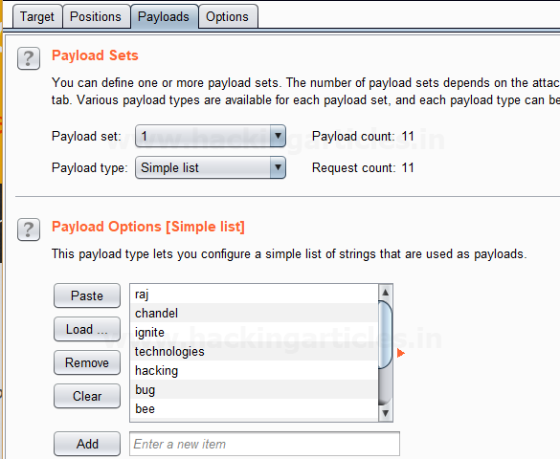

 Before executing the attack we have added a **payload processing** **rule** to the payload type which is **Add Prefix** and we have given an input string “hash” which is added as a **prefix** with every input strings in the dictionary, as shown in the **result window** of the **attack**.

Select **Start Attack** in the **Intruder menu** as shown in the image.

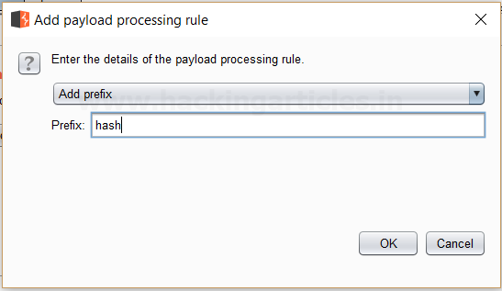

Sit back and relax because now the burp suite will do its work, match the password which will give you the correct password. The moment it will find the correct value, it will change the value of length as shown in the image.

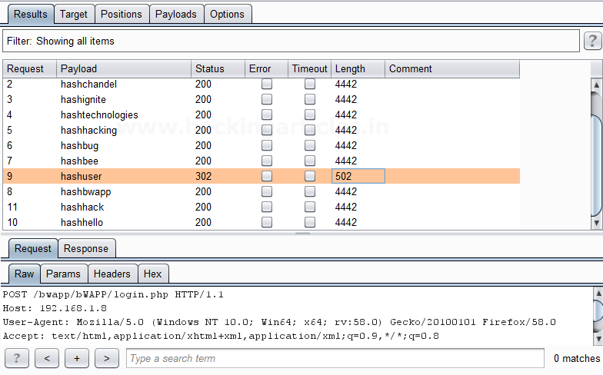

And to confirm the **password matched**, we will give the password in the **Bwapp LAB login page**, which will successfully log us into the **Bwapp lab**. This shows our success in the attack as shown in the image.

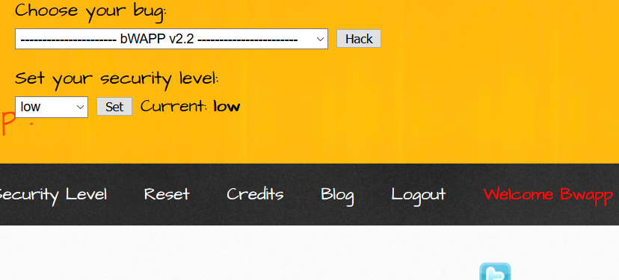

### ****Add Suffix****

This processing rule adds up a suffix after the payload.

First, we have intercepted the request of the login page in the **Bwapp LAB**, where we have given default username and wrong password. Then click on login, the burp suite will capture the request of the login page in the intercept tab.

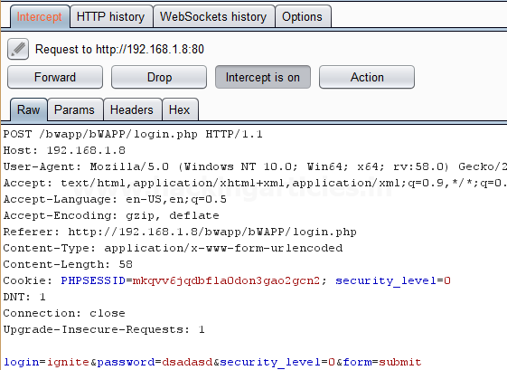

Send the captured request to the**Intruder**by clicking on the Action Tab and follow given below step. Now open the **Intruder tab**then select **Positions tab** and you can observe the highlighted password and follow the given below step for selecting payload position.

* Press on the **Clear button** given at right of the window frame.
* Now we will select the fields where we want to attack and i.e. the password filed and click on **Add button.**
* Choose the **Attack type** as a **sniper**
* In the given below image, we have selected a password that means we will need one dictionary files for a password.

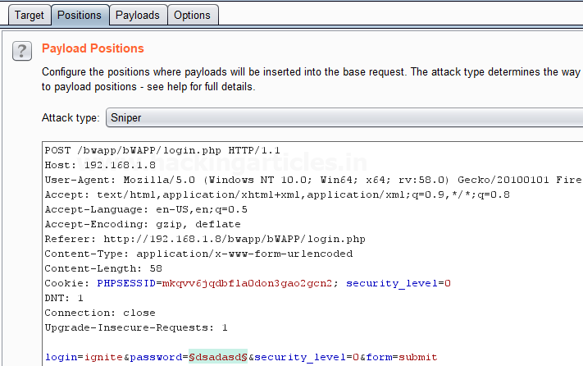

Now click on **payloads option** after selecting payload position. Then select the **Payload type** as **Simple list,** where we have added a dictionary by clicking on **Load** button. We can either load the dictionary or we can manually add input strings using the **Add button** in the **payload options** as shown in the image.

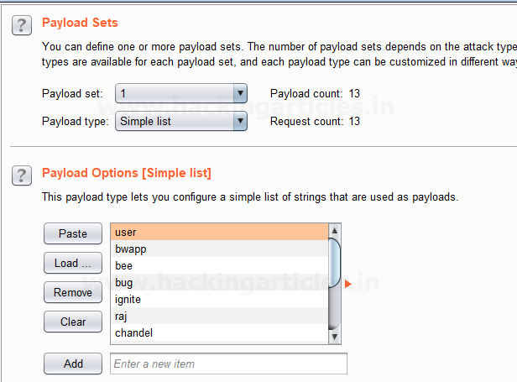

Before executing the attack we have added a **payload processing rule** to the payload type which is **Add Suffix** and we have given an input string “1234” which is added as a **suffix** with every input strings in the dictionary, as shown in the **result window** of the **attack**.

Select **Start Attack** in the **Intruder menu** as shown in the image.

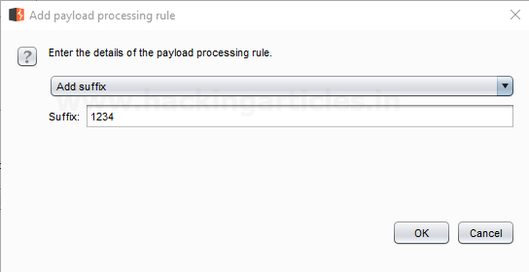

Sit back and relax because now the burp suite will do its work, match the password which will give you the correct password. The moment it will find the correct value, it will change the value of length as shown in the image.

Use this combination of username and password for login to verify your brute force attack for the correct password.

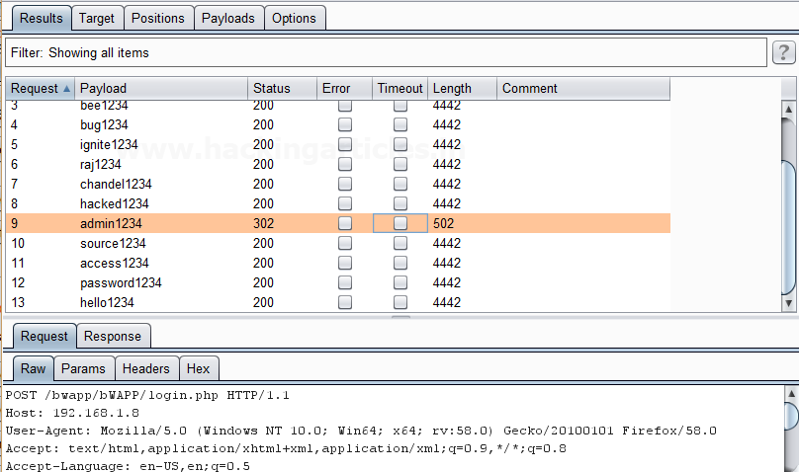

### ****Match / Replace****

This processing rule is used to replace any part of the payload that match a specific regular expression, with a string.

First, we have intercepted the request of the login page in the **Bwapp LAB**, where we have given default username and wrong password. Then click on login, the burp suite will capture the request of the login page in the intercept tab.

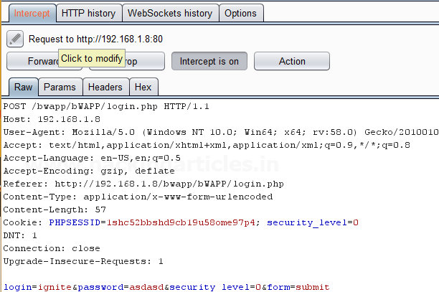

Send the captured request to the**Intruder**by clicking on the Action Tab and follow given below step. Now open the **Intruder tab**then select **Positions tab** and you can observe the highlighted password and follow the given below step for selecting payload position.

* Press on the **Clear button** given at right of the window frame.
* Now we will select the fields where we want to attack and i.e. the password filed and click on **Add button.**
* Choose the **Attack type** as **the sniper**
* In the given below image, we have selected a password that means we will need one dictionary files for the password.

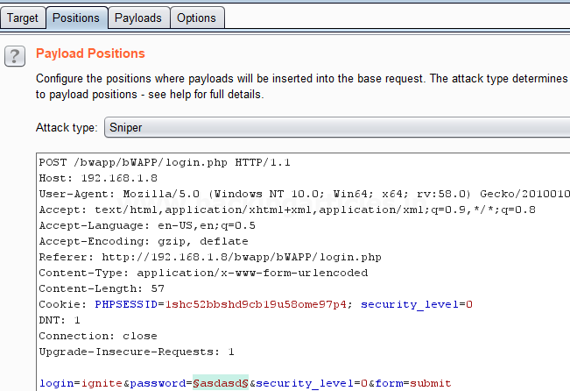

Now click on **payloads option** after selecting payload position. Then select the **Payload type** as **Simple list,** where we have added a dictionary by clicking on **Load** button. We can either load the dictionary or we can manually add input strings using the **Add button** in the **payload options** as shown in the image.

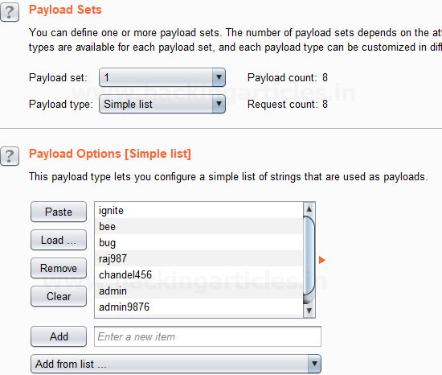

Before executing the attack we have added a **payload processing rule** to the payload type which is **Match / Replace** and we have given an input “9870” in the **Match Regex** which will match the input given with the input strings in the dictionary, if the there is a certain match than it will replace it with the input “1234” given in the **Replace with** as shown in the image.

Select **Start Attack** in the **Intruder menu**.

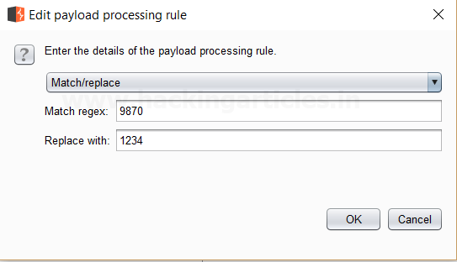

Sit back and relax because now the burp suite will do its work, match the password which will give you the correct password. The moment it will find the correct value, it will change the value of length as shown in the image.

Use this combination of username and password for login to verify your brute force attack for the correct password.

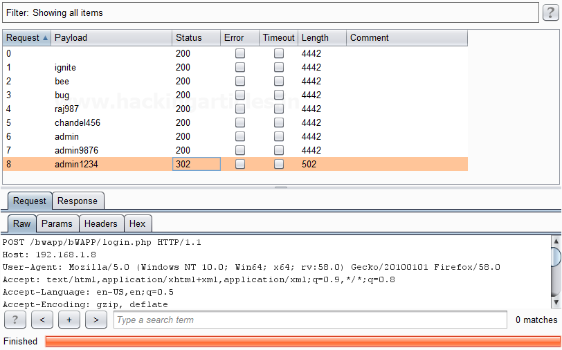

### ****Substring****

This processing rule is used to extracts a sub-portion of the payload, starting from a specified offset up to a specified length. Here the offset and length are counted from the front.

First, we have intercepted the request of the login page in the **Bwapp LAB**, where we have given default username and wrong password. Then click on login, the burp suite will capture the request of the login page in the intercept tab.

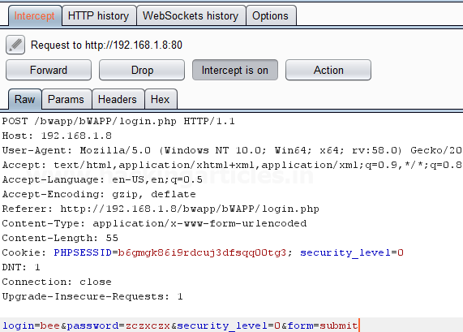

Send the captured request to the**Intruder**by clicking on the Action Tab and follow given below step. Now open the **Intruder tab**then select **Positions tab** and you can observe the highlighted password and follow the given below step for selecting payload position.

* Press on the **Clear button** given at right of the window frame.
* Now we will select the fields where we want to attack and i.e. the password filed and click on **Add button.**
* Choose the **Attack type** as **a sniper**
* In the given below image, we have selected a password that means we will need one dictionary files for the password.

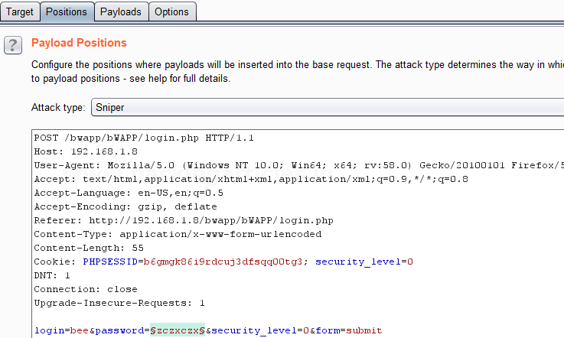

Now click on **payloads option** after selecting payload position. Then select the **Payload type** as **Simple list,** where we have added a dictionary by clicking on **Load** button. Here we had added dictionary using the option “**Add from list**” as shown below in the given image.

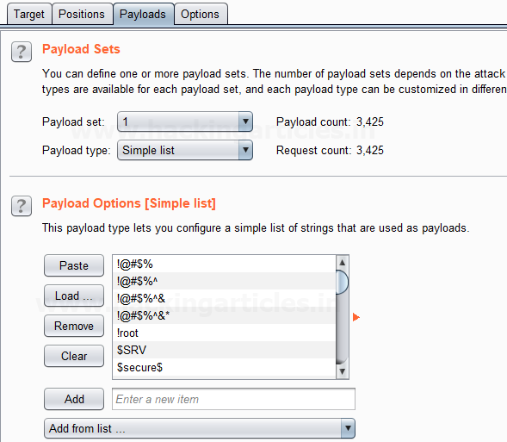

Before executing the attack we have added a **payload processing rule** to the payload type which is **Substring** and we have given an input “0” in **From option** which specifies the offset and an input “3” in the **Length option** which specifies the length of the input strings.

For example, if “password” is a word in a dictionary and we had applied above filter so it will place alphabet **p = 0; a = 1; s = 2 and s = 3** hence it will read only **pass** from whole word “password”.

The length specified will select only those inputs having the specific length and other lower or greater length inputs are discarded as shown in the result window of the attack.

Select **Start Attack** in the **Intruder menu**.

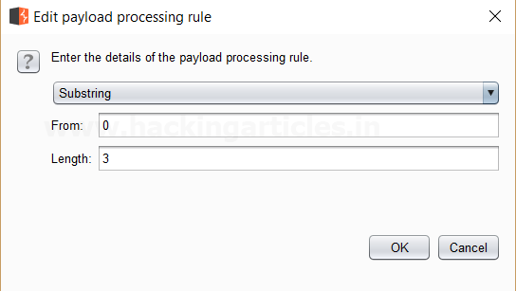

Sit back and relax because now the burp suite will do its work, match the password which will give you the correct password. The moment it will find the correct value, it will change the value of length as shown in the image.

Use this combination of username and password for login to verify your brute force attack for the correct password.

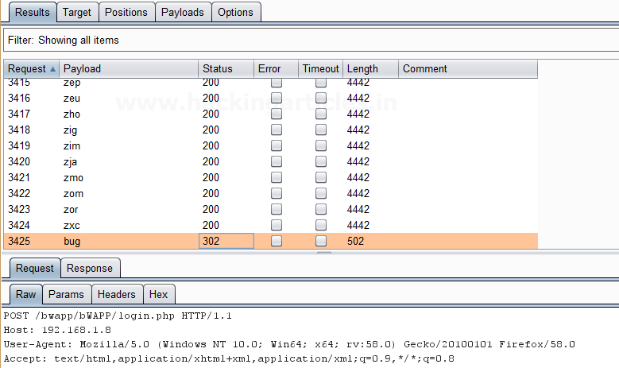

### ****Reverse Substring****

This processing rule is used as a substring rule, but the end offset is specified counting backward from the end of the payload, and the length is counted backward from the end offset.

First, we have intercepted the request of the login page in the **Bwapp LAB**, where we have given default username and wrong password. Then click on login, the burp suite will capture the request of the login page in the intercept tab.

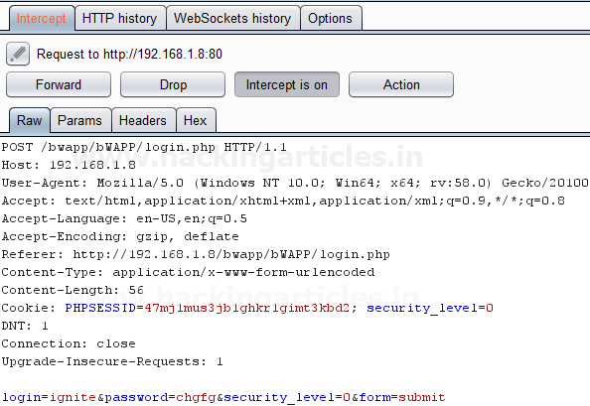

Send the captured request to the**Intruder**by clicking on the Action Tab and follow given below step. Now open the **Intruder tab**then select **Positions tab** and you can observe the highlighted password and follow the given below step for selecting payload position.

* Press on the **Clear button** given at right of the window frame.
* Now we will select the fields where we want to attack and i.e. the password filed and click on **Add button.**
* Choose the **Attack type** as the **sniper**
* In the given below image, we have selected a password that means we will need one dictionary files for a password.

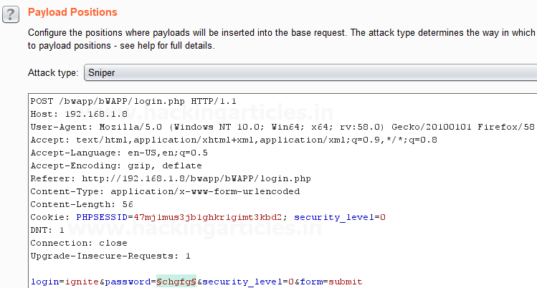

 Now click on **payloads option** after selecting payload position. Then select the **Payload type** as **Simple list,** where we have added a dictionary by clicking on **Load** button. Here we had added dictionary using the option “**Add from list**” as shown below in the given image.

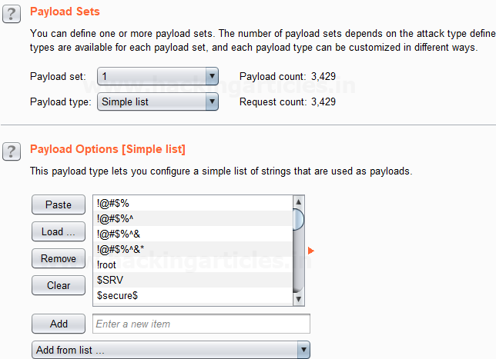

Before executing the attack we have added a **payload processing rule** to the payload type which is **Reverse Substring** and we have given an input “2” in **From option** which specifies the offset and an input “9” in the **Length option** which specifies the length of the input strings and they are similar to the Substring rule but it works from backward of an offset and the length is counted backward where the offset ends.

For example if “admin123456” is word in dictionary and we had applied above filter so it will place alphabet **4 = 0; 3 = 1 ; 2 = 2 ; 1 = 3 ; n = 4 ; i = 5 ; m = 6 ; d = 7 ; d = 8 ; a = 9** hence it will read  only ‘**admin1234’** from whole word “admin123456”.

The length specified will select only those inputs having the specific length and other lower or greater length inputs are discarded as shown in the result window of the attack.

Select **Start Attack** in the **Intruder menu**.

Sit back and relax because now the burp suite will do its work, match the password which will give you the correct password. The moment it will find the correct value, it will change the value of length as shown in the image.

Use this combination of username and password for login to verify your brute force attack for the correct password.

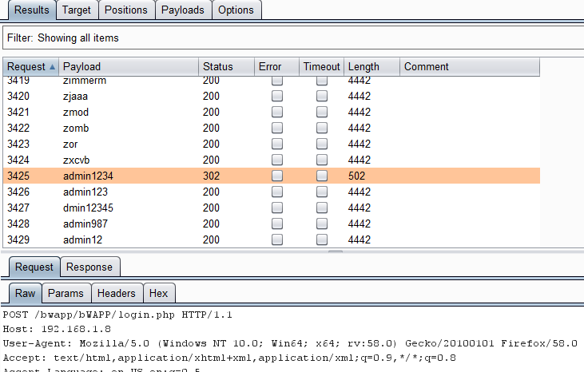

**Modify Case**

This processing rule can be used to modify the case of the payload if needed. This rule has the same options available for the **Case Modification** payload type which we have explained in **Part-1** of the **Payload types article**.

**Source: portswigger.net**

# Payload Processing Rule in Burp suite (Part 2)

[February 6, 2018](https://www.hackingarticles.in/payload-processing-rule-burp-suite-part-2/) By [Raj Chandel](https://www.hackingarticles.in/author/raaj/)

Today we are going to discuss “Payload Encoding” option followed by payload processing of Burpsuite which is advanced functionality comes under **Intruder Tab** for making brute force attack.

### ****Payload Encode****

The processing rule can be used to encode the payload using various schemes such as URL, HTML, Base64, ASCII hex or constructed strings.

**Let’s start!!**

First, we have intercepted the request of the login page of the router by giving its **default IP** which is **192.168.1.1**, where we have given an invalid username and password. Then click on login, the burp suite will capture the request of the login page in the intercept tab.

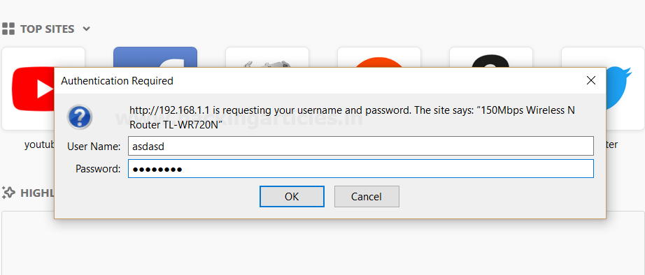

Thus the sent request will be captured by burp suite which you can see in the given below image. In the screenshot, I had highlighted some value in the last line. Here it tells the type of authentication provided by the router is **basic** and if you have read above theory of basic authentication I had described that it is **encoded** in **base 64**

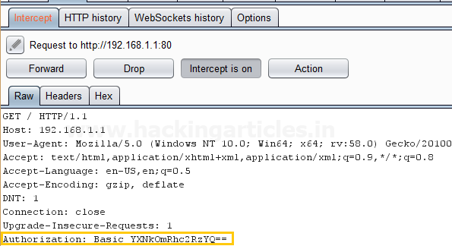

Send the captured request to the**Intruder**by clicking on the Action Tab and follow given below step. Now open the **Intruder tab**then select **Positions tab** and you can observe the highlighted password and follow the given below step for selecting payload position.

* Press on the **Clear button** given at right of the window frame.
* Now **select** the **encoded value of authentication** for payload position and **click** to **ADD button** on the left side of the frame.
* Choose the **Attack type** as

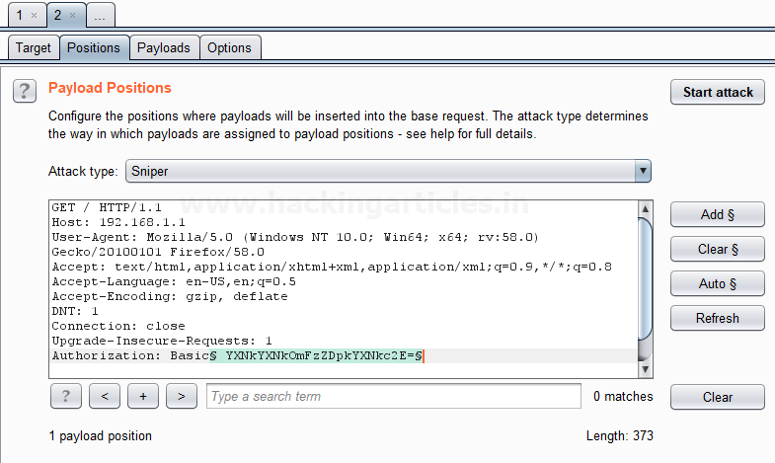

Now click on **payloads option** after selecting payload position. Then select the **Payload type** as **Simple list,** where we have added a dictionary by clicking on **Load** button. We can either load the dictionary or we can manually add input strings using the **Add button** in the **payload options** as shown in the image.

The base64 encoded value of Authentication is a combination of username and password now the scenario is to generate the same encoded value of authentication with help of user password dictionary, therefore I have made a **dictionary.**

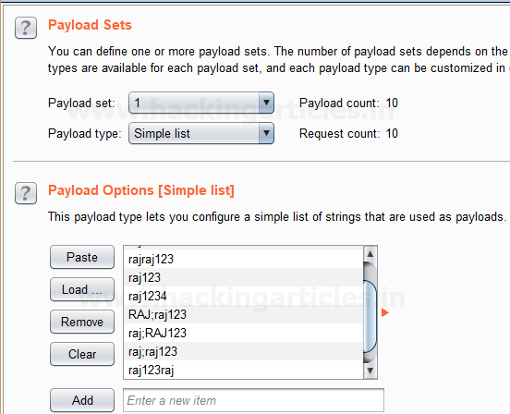

Before executing the attack we have added a **payload processing rule** to the payload type which is **Encode** and we have selected **“Base64 encode”**scheme because we know router takes the value in **Base64**.

Select **Start Attack** in the **Intruder menu** as shown in the image.

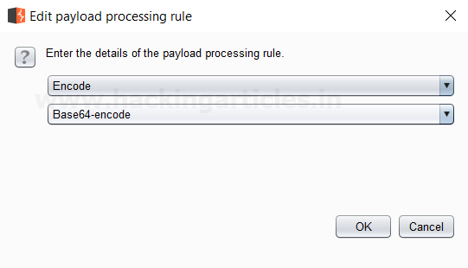

Sit back and relax because this will start brute force attack and try to match string for user authentication. In the screenshot, you can the **status** and **length**of the **highlighted value**is **different**from the rest of the values. This means we can use this encoded value to bypass the user authentication which occurs from request number 10. Now check the username and password of 10th line in the dictionary.

And to confirm the **username** and **password matched**, we will give the password in the **Router’s Login Page**, which will successfully log us into the **Router’s Configuration Page**. This shows our success in the attack as shown in the image.

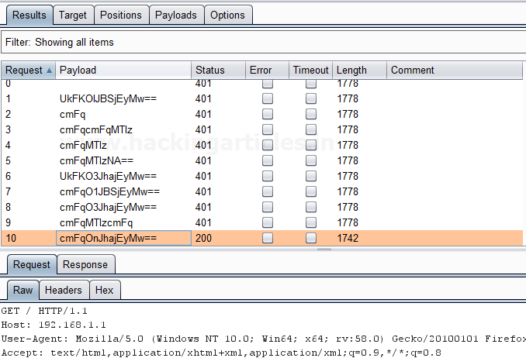

### ****Decode****

This processing rule can be used to decode the payload using various schemes: URL, HTML, Base64 or ASCII hex. As we know decoding is nothing but reversing the encoding. It can be used in the opposite way in which encoding is carried out.

**Hash**

This processing rule can be used to carry out a hashing operation on the payload. There are 7 types of hashing algorithms are available in this payload processing rule which is as follows:

* SHA-384
* SHA-224
* SHA-256
* MD5
* MD2
* SHA
* SHA-512

First, we have intercepted the request of the **Redirection Link** designed to find **redirection vulnerabilities** in the**LAB**created by us and in the hash value of the URL we have given a wrong hash value of **HTTP://www.google.com** in place of the **actual hash value** of the **HTTP://www.hackingarticles.in** in the **URL** of the redirecting page. We have simply clicked on the Redirection link as shown in the image; the burp suite will capture the request of the redirecting page in the intercept tab.

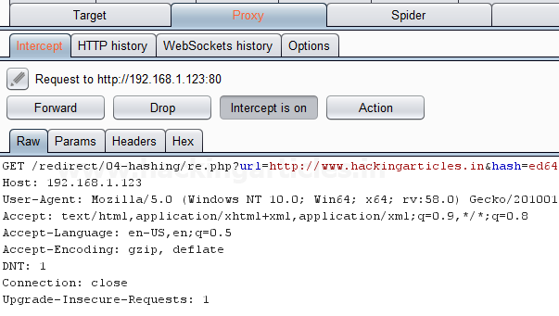

Send the captured request to the**Intruder**by clicking on the Action Tab and follow given below step. Now open the **Intruder tab**then select **Positions tab** and you can observe the highlighted password and follow the given below step for selecting payload position.

* Press on the **Clear button** given at right of the window frame.
* Now we will select the fields where we want to attack which is the **hash value** of the redirecting page and then click on **the Add button.**
* Choose the **Attack type** as a sniper.

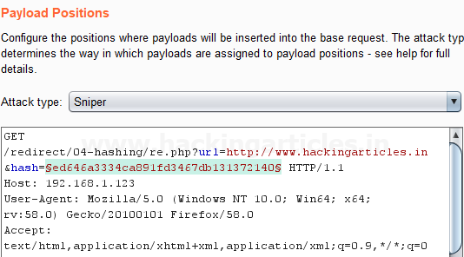

Then select the **Payload type** as **Simple list,** where we have added a dictionary by clicking on **Load** button. We can either load the dictionary or we can manually add input strings using the **Add button** in the **payload options** as shown in the image.

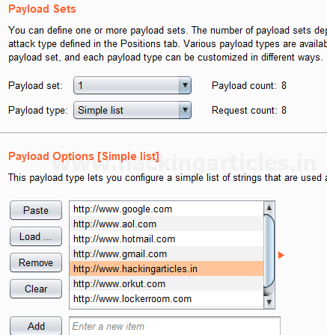

Before executing the attack we have added a **payload processing rule** to the payload type which is **Hash** and then we have selected **MD5**which is a commonly used algorithm for converting URL of the websites into a Hash MD5 value. As you can see the **input strings** of the dictionary are in a simple text form, but this processing rule converts it into Hash MD5 values which can be seen in **result window** of the **attack**.

Select **Start Attack** in the **Intruder menu** as shown in the image.

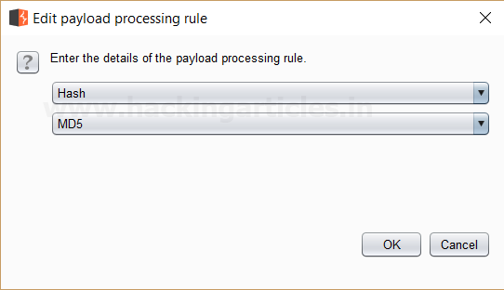

Sit back and relax because now the burp suite will do its work, match the Hash MD5 of the Redirecting Page which will give you the correct MD5 value. The moment it will find the correct value, it will change the value of length as shown in the image.

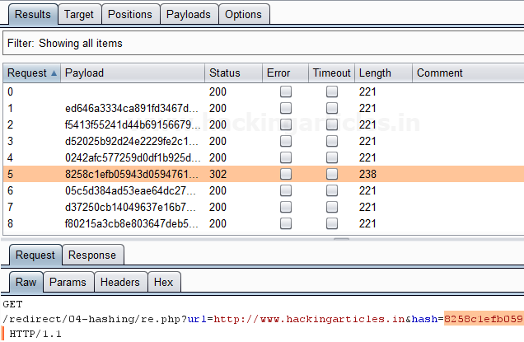

The **Hash MD5 value**, we will give the Hash value in the **URL**of the redirecting page which is **HTTP://www.hackingarticles.in**, which will successfully redirect us to**HTTP://www.hackingarticles.in**. This shows our success in the attack as shown in the image.

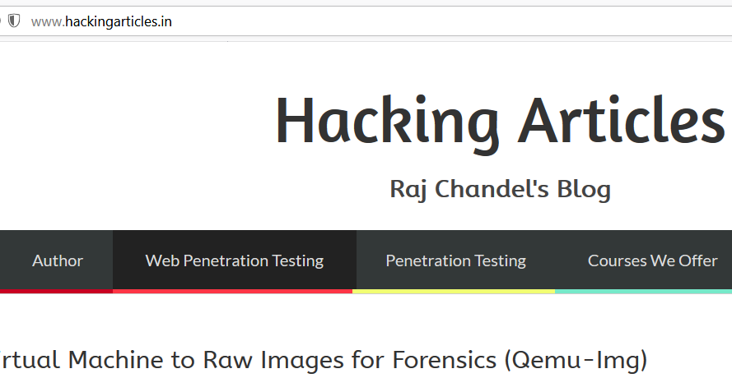

### ****Add Raw Payload****

This processing rule can be used to add raw payload value before or after the current processed value. For example, it can come in handy whenever we want to submit the same payload in both raw and hashed form.

First, we have intercepted the request of the login page in the **Bwapp LAB**, where we have given default username and wrong password. Then click on login, the burp suite will capture the request of the login page in the intercept tab.

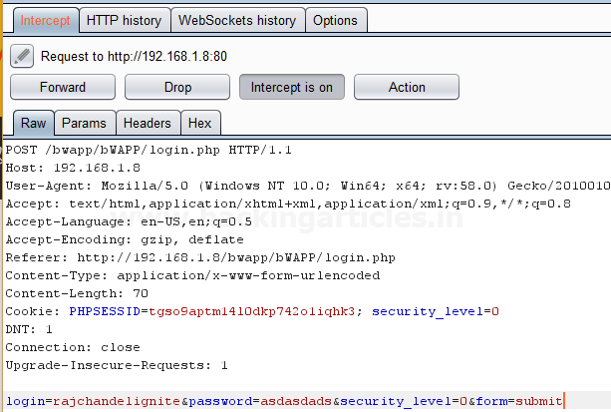

Send the captured request to the**Intruder**by right-clicking on the space and selecting **Send to Intruder**option or simply press **Ctrl + i**. Now open the **Intruder tab**then select **Positions tab** and the following will be visible. Choose the **Attack type** as **Sniper.**Press on the **Clear button** as shown in the image. Now we will select the fields where we want to attack which is the password and click on **Add button.**

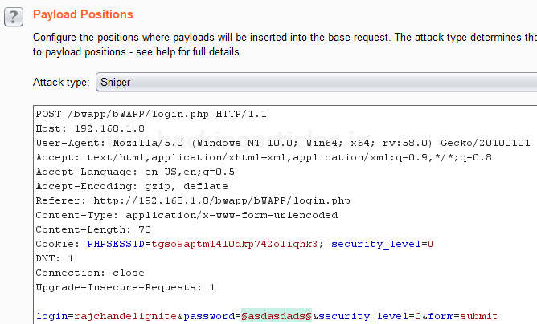

Send the captured request to the**Intruder**by clicking on the Action Tab and follow given below step. Now open the **Intruder tab**then select **Positions tab** and you can observe the highlighted password and follow the given below step for selecting payload position.

* Press on the **Clear button** given at right of the window frame.
* Now we will select the fields where we want to attack and i.e. the password filed and click on **Add button.**
* Choose the **Attack type** as
* In the given below image, we have selected a password that means we will need one dictionary files for a password.

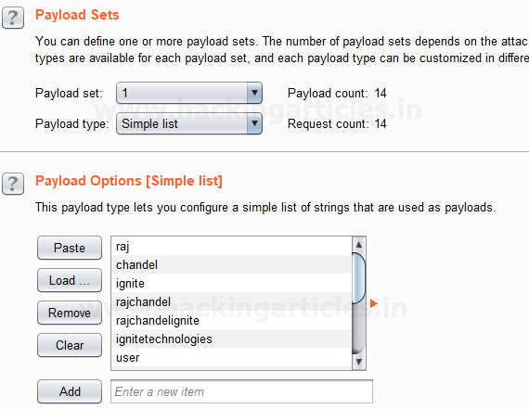

Before executing the attack we have added a payload processing rule to the payload type which is **Add Raw Payload** and then we have selected **Append Pre-processed Payload**. This adds a **raw payload value** before and after the **current processed value**. As you can see the **input strings** of the dictionary as a single input string is **repeated twice** which can be seen in **result window** of the **attack**.

Select **Start Attack** in the **Intruder menu** as shown in the image.

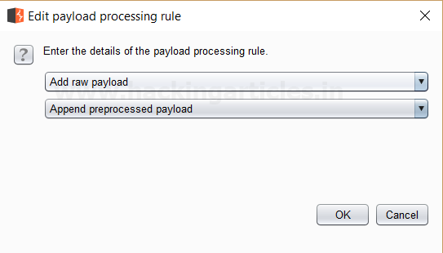

Sit back and relax because now the burp suite will do its work, match the password which will give you the correct password. The moment it will find the correct value, it will change the value of length as shown in the image.

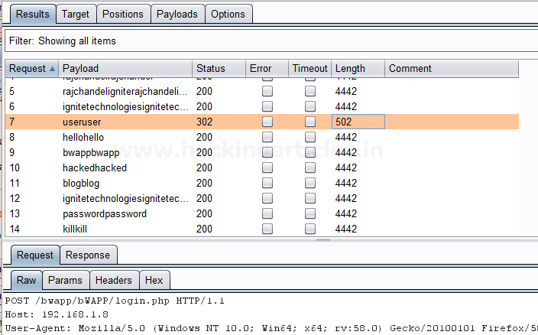

And to confirm the **password matched**, we will give the password in the **Bwapp LAB login page**, which will successfully log us into the **Bwapp lab**. This shows our success in the attack as shown in the image.

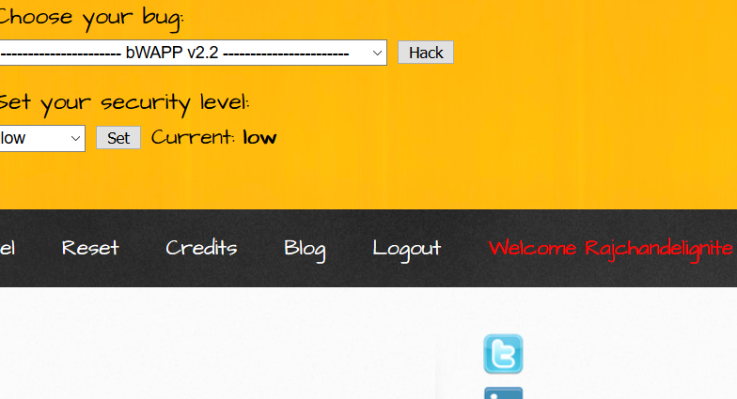

### ****Skip if Matches Regex****

This processing rule can be used to check the current processed value matches a specified regular expression, and if it matches it will skip the payload and will move onto the next one. For example, Suppose we have a parameter value that has a minimum length and want to skip values in the list that are shorter than the minimum length defined.

First, we have intercepted the request of the login page in the **Bwapp LAB**, where we have given default username and wrong password. Then click on login, the burp suite will capture the request of the login page in the intercept tab.

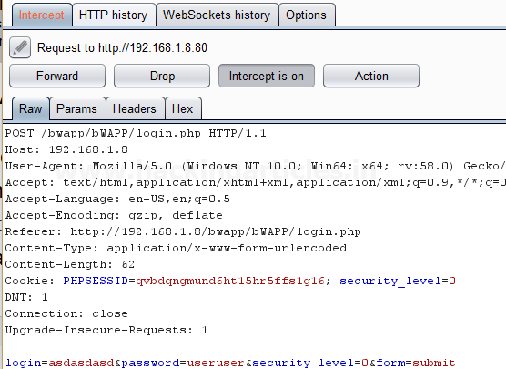

Send the captured request to the**Intruder**by clicking on the Action Tab and follow given below step. Now open the **Intruder tab**then select **Positions tab** and you can observe the highlighted password and follow the given below step for selecting payload position.

* Press on the **Clear button** given at right of the window frame.
* Now we will select the fields where we want to attack and i.e. the password filed and click on **Add button.**
* Choose the **Attack type** as
* In the given below image, we have selected a password that means we will need one dictionary files for a password.

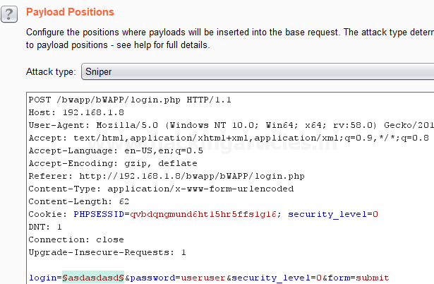

Then select the **Payload type** as **Simple list,** where we have added a dictionary by clicking on **Load** button. We can either load the dictionary or we can manually add input strings using the **Add button** in the **payload options** as shown in the image.

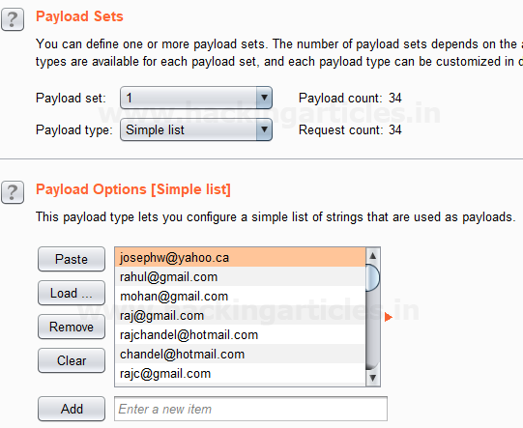

Before executing the attack we have added a payload processing rule to the payload type which is **Skip if Matches Regex** where we have given an input of **{@}** in the **match regex** field. Here we see that as per this rule if the input is given matches with any of the input strings in the dictionary it simply skip that value and move on to next.

Now Select **Start Attack** in the **Intruder menu** as shown in the image.

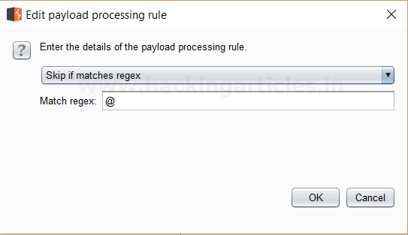

Sit back and relax because now the burp suite will do its work, match the password which will give you the correct password. The moment it will find the correct value, it will change the value of length as shown in the image.

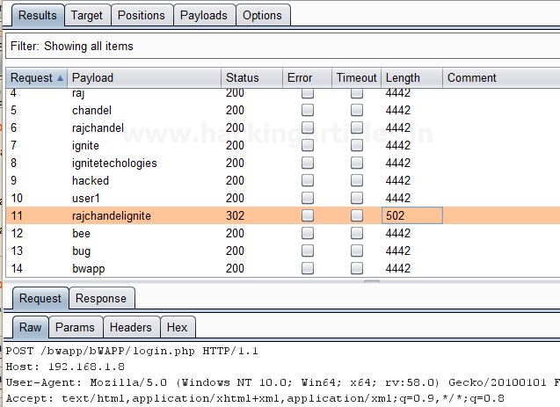

# Beginners Guide to Burpsuite Payloads (Part 1)

[January 22, 2018](https://www.hackingarticles.in/beginners-guide-burpsuite-payloads-part-1/) By [Raj Chandel](https://www.hackingarticles.in/author/raaj/)

Hello friends!! Today we are discussing about the “Types of Payload in Burp Suite”. Burp Suite is an application which is used for testing Web application security. Its various tools work seamlessly together to support the entire testing process, from initial mapping and analysis of an application’s attack surface, through to finding and exploiting security vulnerabilities. This tool is written in JAVA and is developed by PortSwigger Security. We are going to use the Intruder feature of Burp Suite, it is used to brute force web applications. There are 18 types of payloads in intruder i.e.

* **Simple list**
* **Runtime File**
* **Case Modification**
* **Numbers**
* **Character substitution**
* **Custom iterator**
* **Recursive grep**
* **Illegal Unicode**
* **Character blocks**
* **Dates**
* **Brute Forcer**
* **Null Payloads**
* **Character frober**
* **Bit Flipper**
* **Username generator**
* **ECB block shuffler**
* **Extension Generated**
* **Copy other payload**

### ****Simple List****

This is one of the simple types of payload, as it allows you to configure a short Dictionary of strings which are used as payload.

First, we intercept the request of the login page in the **DVWA LAB**, where we have given a random username and password. Then click on login, the burp suite will capture the request of the login page.

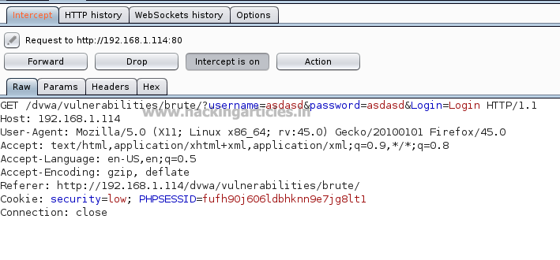

Send the captured request to the**Intruder**by clicking on the Action Tab and follow given below step. Now open the **Intruder**tab then select **positions** and you can observe the highlighted username and password and follow the given below step for selecting payload position.

* Press on the **Clear button** given at right of window frame.
* Now we will select the fields where we want to attack which is the username and password and click on **Add button.**
* Choose the **Attack type** as **Cluster Bomb.**
* In the given below image we have selected username and password that means we will need two dictionary files i.e. one for username and second for password.

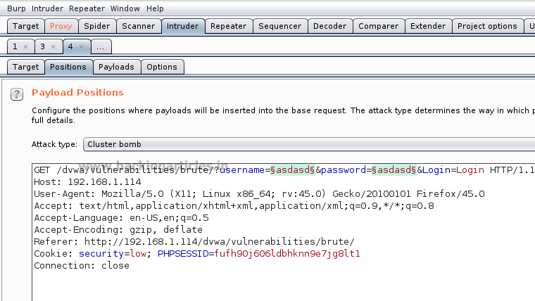

So now, go to **Payloads tab**and the select **1** from **Payload set**(this ‘1’ denotes the first file to be selected). Then click on **Load** button **and select**your dictionary file for username.

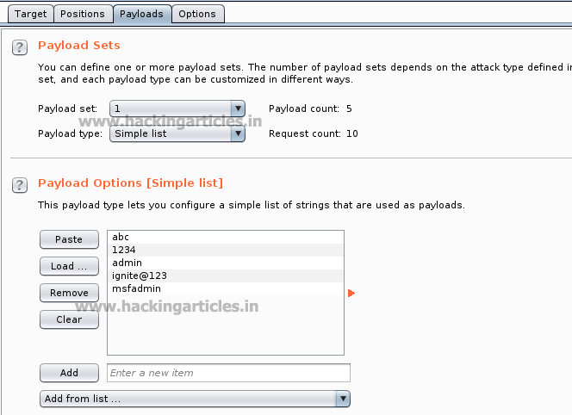

Now select **2** in the **Payload set**and again give the dictionary file for the password. Select **Start Attack** in the **Intruder menu** as shown in the image.

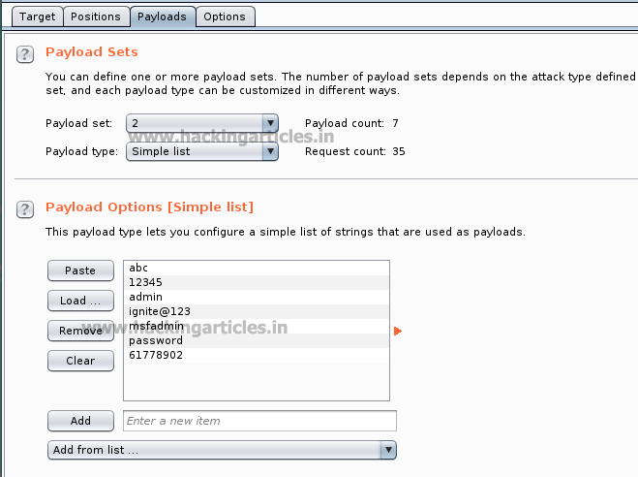

Now the burp suite will do its work, match the valid combination of username and password and will give you the correct password and username. The moment it will find the correct value, it will change the value of length as shown.

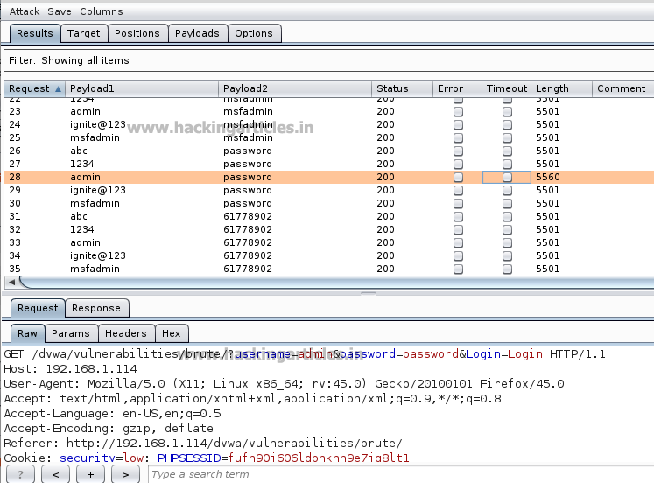

And to confirm the username and password matched, we will give the matched username and password in the**DVWA LAB login page**. We will see a message **“Welcome to the password protected area admin”**which shows are success in the simple list payload attack.

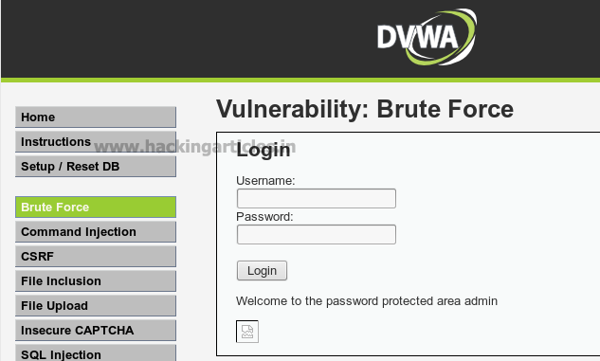

### ****Runtime File****

This type of payload allows you to configure a file which reads the payload strings at runtime. This type of payload is needed when we require a large list of payloads, to avoid holding the entire list in memory. This payload allows you to configure large list of strings which overcomes the simple list payload type.

First, we have intercepted the request of the login page in the **DVWA LAB**, where we have given a random username and a random password. Then click on login, the burp suite will capture the request of the login page in the intercept tab.

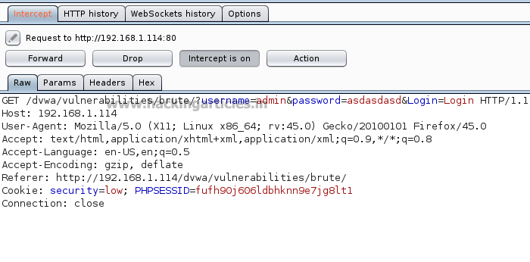

Send the captured request to the**Intruder**and follow given below step. Now open the **Intruder tab**then select **positions**and you can observe the highlighted password and follow the given below step for selecting payload position.

* Press on the **Clear button** given at right of window frame.
* Now we will select the fields where we want to attack and i.e. the password filed and click on **Add button.**
* Choose the **Attack type** as
* In the given below image we have selected  password that means we will need one dictionary file  for password.

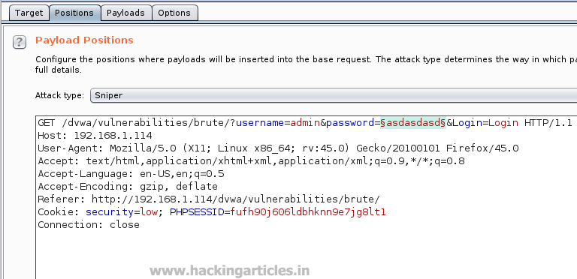

Then select the “Payload type” as **Runtime File** and then give the path of dictionary in the “payload options” as **/usr/share/wordists/rockyou.txt** which is the largest dictionary in **Kali Linux**. Select **Start Attack** in the **Intruder menu**.

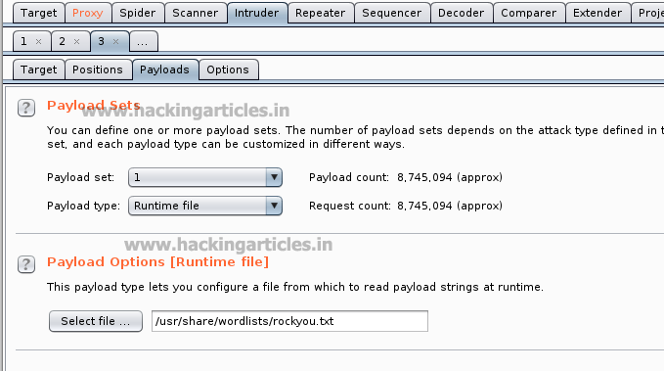

Now the burp suite will do its work, match the password and will give you the correct password. The moment it will find the correct value, it will change the value of length as shown.

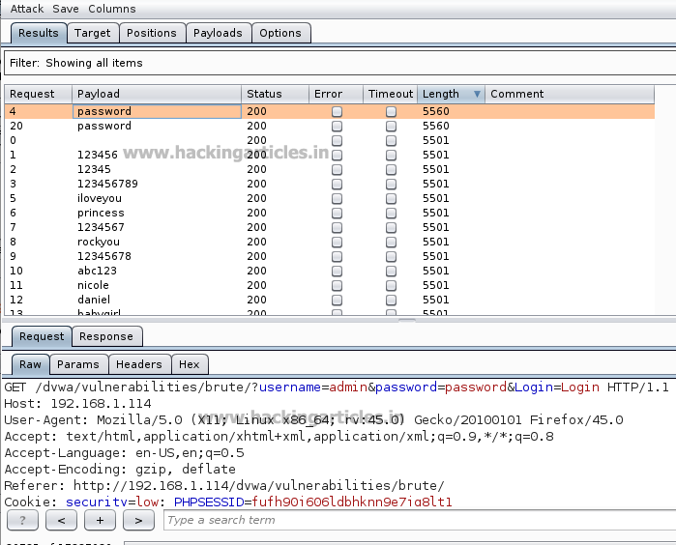

### ****Case Modification****

This type of payload allows you to configure a list of strings and apply various case modifications to each item on the list. This is useful in password guessing attacks, for generating case variations on dictionary words.

The following case modification rules can be selected:

* **No change** – The item is used without being modified.
* **To lower case** – All letters in the item are converted to lower case.
* **To upper case** – All letters in the item are converted to upper case.
* **To Proper name** – The first letter in the item is converted to upper case, and the remaining letters are converted to lower case.
* **To Proper Name** – The first letter in the item is converted to upper case, and the remaining letters are not changed.

For example, if we select all the modification options, then the item “Raj Chandel” will generate the following payloads:

Raj Chandel

raj chandel

RAJ CHANDEL

Raj chandel

First, we intercept the request of the login page in the **DVWA LAB**, where we have given a random username and a random password. Then click on login , the burp suite will capture the request of the login page in the intercept tab. Send the captured request to the**Intruder**by right clicking on the space and selecting **Send to Intruder**option or simply press **ctrl + i**.

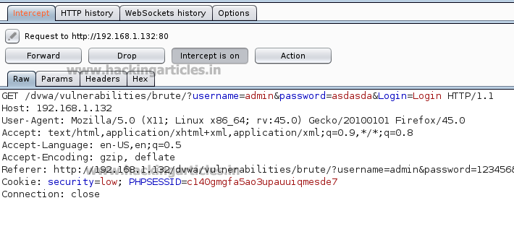

Now open the **Intruder tab**then select **positions** and you can observe the highlighted password and follow the given below step for selecting payload position.

* Press on the **Clear button** given at right of window frame.
* Now we will select the fields where we want to attack and i.e. the password filed and click on **Add button.**
* Choose the **Attack type** as
* In the given below image we have selected  password that means we will need one dictionary file  for password.

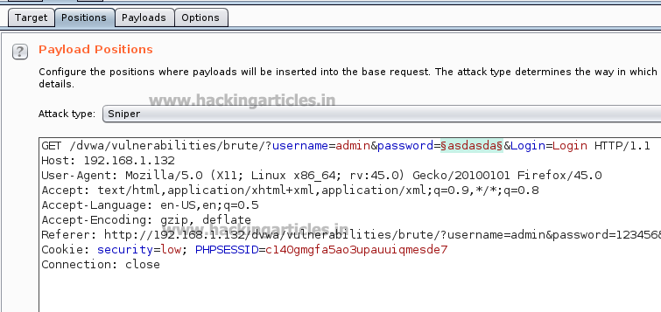

Then select the “Payload” type as **Case Modification,**we have selected the **No change** and **to lower case** fields in the “payload options” of the case modification as shown in the image. We have added a default **Password dictionary** from the **Add from list** field in the payload options. Select **Start Attack** in the **Intruder menu** as shown in the image.

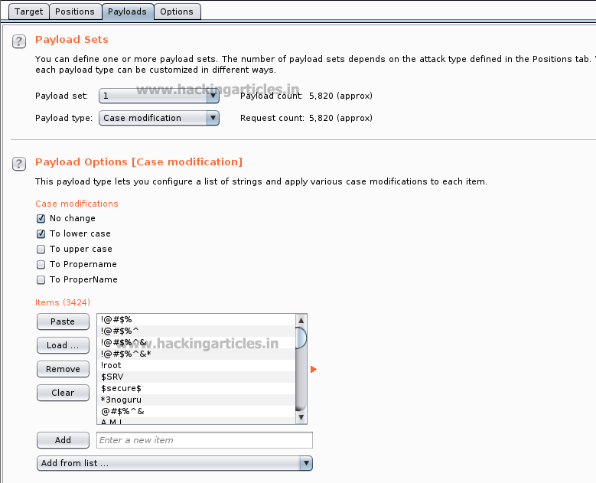

Now the burp suite will do its work, match the password and will give you the correct password. The moment it will find the correct value, it will change the value of length as shown.

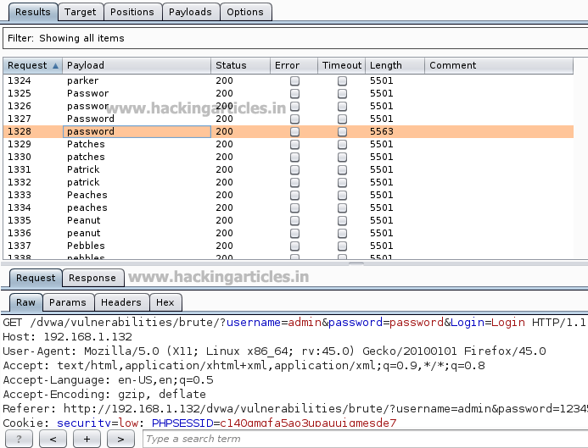

### ****Numbers****

This type of payload generates numeric payloads within a given range and in a specified format.

The following options are available in this payload:

* Number range:
* **Type** – the type options describes that the numbers should be generated sequentially or randomly.
* **From** – If numbers are being generated sequentially, this is the value of the first number that will be generated.
* **To** – If numbers are being generated sequentially, this value of the last number that will be generated. It is said as the highest possible number that may be randomly generated.
* **Step** – the step option is used when numbers are being generated sequentially and specifies the increment in the successive numbers.
* **How many** – This option is available when numbers are being generated randomly, and specifies the number of payloads that will be generated

First, we intercept the request of the login page in the **Bwapp Lab**, where we have given a random username and a random password. Then click on login, the burp suite will capture the request of the login page.

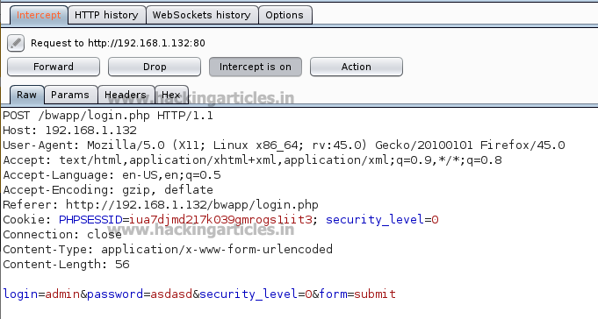

Send the captured request to the**Intruder**and follow given below step. Now open the **Intruder tab**then select **positions**and you can observe the highlighted password and follow the given below step for selecting payload position.

* Press on the **Clear button** given at right of window frame.
* Now we will select the fields where we want to attack and i.e. the password filed and click on **Add button.**
* Choose the **Attack type** as
* In the given below image we have selected  password that means we will need one dictionary file  for password.

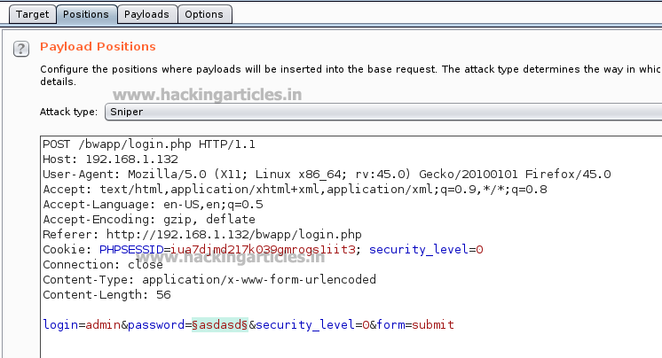

Then select the **Payload type** as **Numbers**where we have set the **number range from 100 to 150** and we have set the **step as 1**as shown in the image**,**select **Start Attack** in the **Intruder menu**.

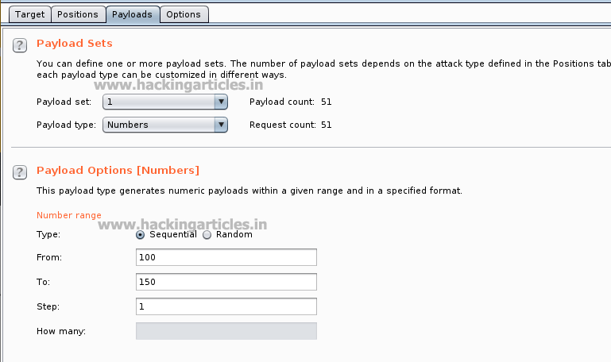

Now the burp suite will do its work, match the password and will give you the correct password. The moment it will find the correct value, it will change the value of length as shown.

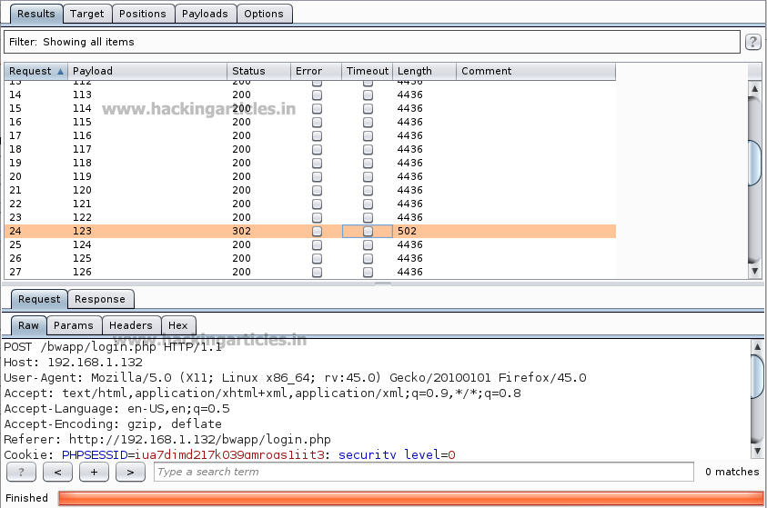

As the password matches with a number which is between the given number range. And to confirm the password matched, we will give the password in the **Bwapp LAB login page**, which will successfully log us into the **Bwapp lab**. This shows our success in the attack.

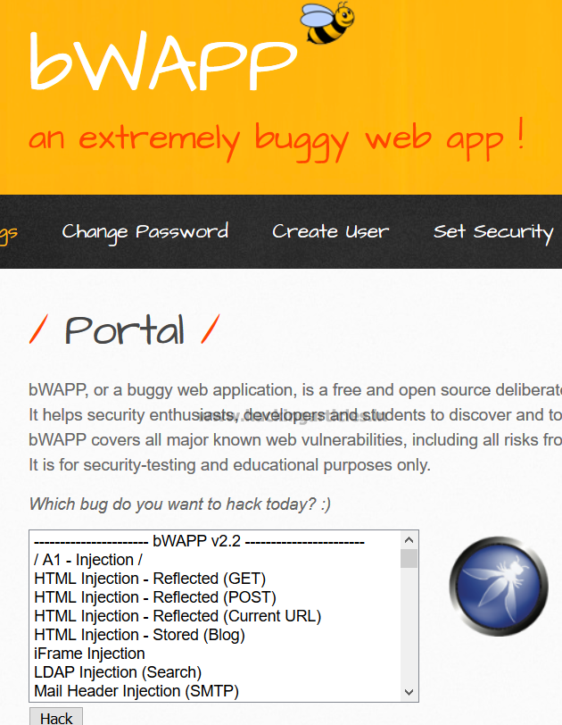

### ****Brute Forcer****

This type of payload generates a payload of specified lengths that contain all permutations of list of characters in the given string.

The following options are available:

* **Character set** – The set of characters to be used in the payloads. Note that the total number of payloads increases exponentially with the size of this set.
* **Min length** – The length of the shortest payload.
* **Max length** – The length of the longest payload.

First, we intercept the request of the login page in the **Bwapp LAB**, where we have given a random username and a random password. Then click on login, the burp suite will capture the request of the login page.

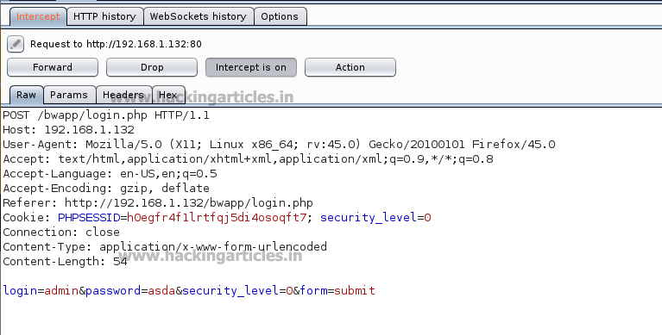

Send the captured request to the**Intruder** and follow given below step. Now open the **Intruder tab**then select **positions** and you can observe the highlighted password and follow the given below step for selecting payload position.

* Press on the **Clear button** given at right of window frame.
* Now we will select the fields where we want to attack and i.e. the password filed and click on **Add button.**
* Choose the **Attack type** as
* In the given below image we have selected  password that means we will need one dictionary file  for password.

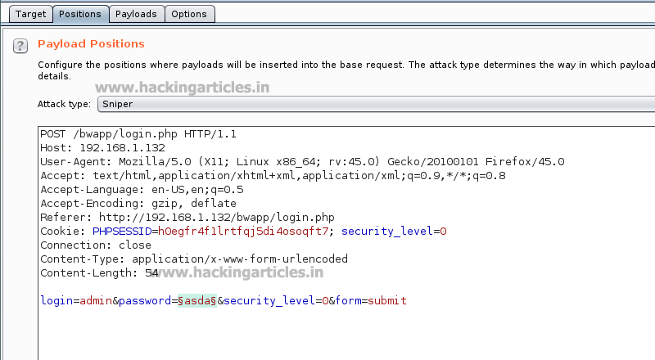

Then select the “Payload type” as **Brute Forcer**where we can give any kind of input into the “character set” as shown in the figure , as we have given **213**and we have set the Min length as 3 and Max length as 3 as shown in the image. We can manually give the **Min length**and**Max length** as per your need. Select **Start Attack** in the **Intruder menu** as shown in the image.

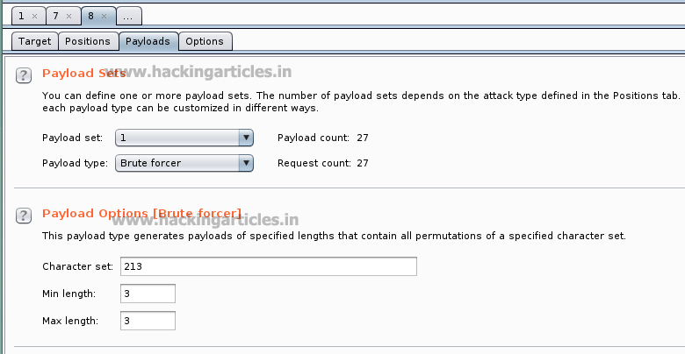

Now the burp suite will do its work, match the password and will give you the correct password. The moment it will find the correct value, it will change the value of length as shown.



**Great!!** We have used Top 5 payloads of Burpsuite for login page brute force attack successfully.

**Note: In this articles (part-1) we will be performing top 5 payload types and the rest of the payload types will be discussed in the (part-2) of this article.**

# Beginners Guide to Burpsuite Payloads (Part 2)

[January 29, 2018](https://www.hackingarticles.in/beginners-guide-burpsuite-payloads-part-2/) By [Raj Chandel](https://www.hackingarticles.in/author/raaj/)

In our [**previous**](https://www.hackingarticles.in/beginners-guide-burpsuite-payloads-part-1/) article part1, we had discussed how to perform a brute force attack on any web application server for making unauthorized login into it using some Payload of Burpsuite. In part 2 articles you will learn more about brute force attack with help of remaining BurpSuite payloads that might be helpful in other situation.

**Let’s Start!!**

### ****Character Substitution****

This type of payload allows to configure a list of strings and apply various character substitutions to each item. This type of payload is useful in password guessing attacks and generating common variations on dictionary words.

The UI of this payload allows you to configure a number of character substitutions. For each item, it will generate a number of payloads, which include all permutations of substituted characters according to the defined substitutions.

 For example, the default substitution rules states (which include**e > 4 and r > 5**), the item **“Raj Chandel”** will generate the following payloads:

**raj chandel**

**5aj chandel**

**raj chand4l**

**5aj chand4l**

First, we have intercepted the request of the login page in the **DVWA LAB**, where we have given a default username and wrong password. Then click on login, the burp suite will capture the request of the login page in the intercept tab.

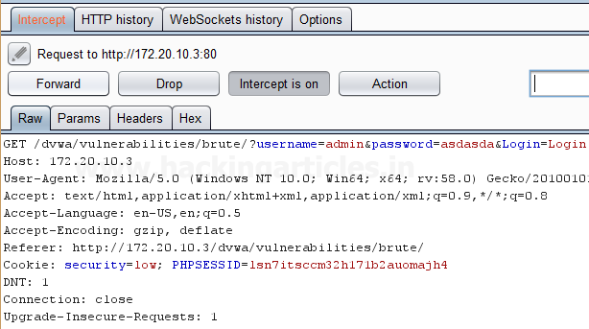

Send the captured request to the**Intruder**by clicking on the Action Tab and follow given below step. Now open the **Intruder tab**then select **Positions tab** and you can observe the highlighted password and follow the given below step for selecting payload position.

* Press on the **Clear button** given at right of the window frame.
* Now we will select the fields where we want to attack and i.e. the password filed and click on **Add button.**
* Choose the **Attack type** as
* In the given below image, we have selected a password that means we will need one dictionary files for a password.

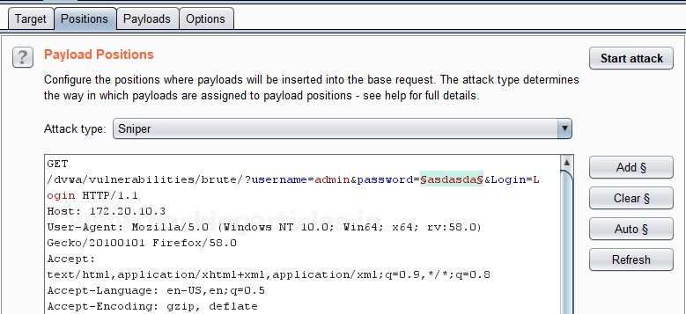

 Now click on **payloads option** after selecting payload position. Here we can add a dictionary by clicking on **Load option** or we can manually add**Strings** by clicking on the **Add option.**

Now we have substituted **4>a, 5>s, 9>o** as per our requirements to match the password and we have added the input as **p445w9rd** using the **Add option**which will substitute the character’s according to the **Defined substitution**as shown in the image.

**Start Attack** in the **Intruder menu** as shown in the image.

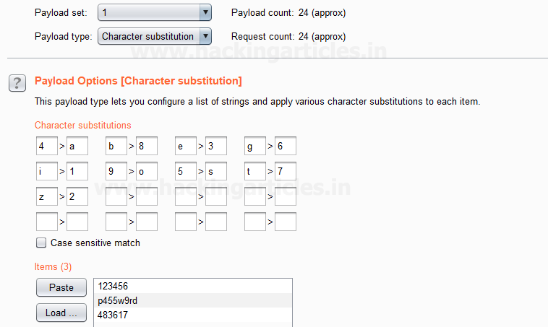

Sit back and relax because now the burp suite will do its work, match the password and will give you the correct password. The moment it will find the correct value, it will change the value of length as shown.

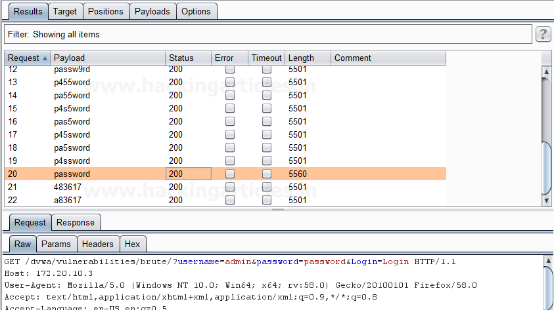

 And to confirm the password matched, we will give the matched password in the**DVWA LAB login page**. We will see a message **“Welcome to the password protected area admin” which shows our success in the character substitution payload attack.**

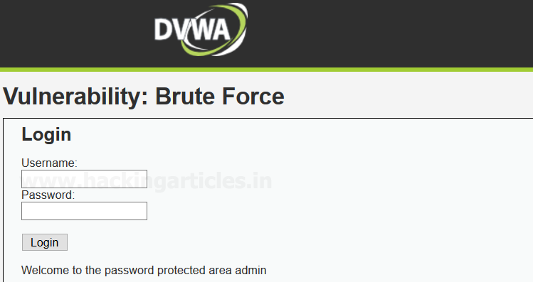

### ****Copy Other Payload****

This is a type of payload which can copy the value of the current payload to another payload position. It is very useful for attack types that have multiple payload sets such as cluster bomb, pitchfork, and battering ram. This payload type can be useful in various situations, for example:

* Suppose we are using two different parameters and we want to attack at two different fields, therefore we can set different “payload types” at multiple “payload sets” inside burpsuite payload configuration as per our attack type as it allows us to simply use the same dictionary for both payloads that we have set at particular position by giving the position of the payload we want to copy. It will execute the complete payload which is set at a specific position.

First, we have intercepted the request of the login page in the **Bwapp LAB**, where we have given wrong username and password. Then click on login, the burp suite will capture the request of the login page in the intercept tab.

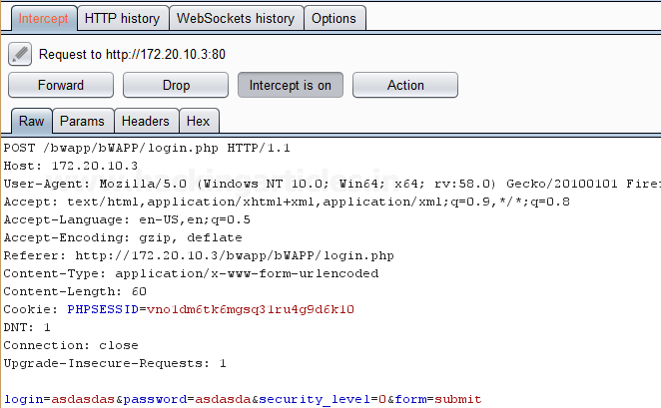

Send the captured request to the**Intruder**by clicking on the Action Tab and follow given below step. Now open the **Intruder tab**then select **Positions tab** and you can observe the highlighted username and password and follow the given below step for selecting payload position.

* Press on the **Clear button** given at right of the window frame.
* Now we will select the fields where we want to attack which is the username and password and click on **Add button.**
* Choose the **Attack type** as **Cluster Bomb.**
* In the given below image, we have selected username and password that means we will need two dictionary files i.e. one for username and second for a password.

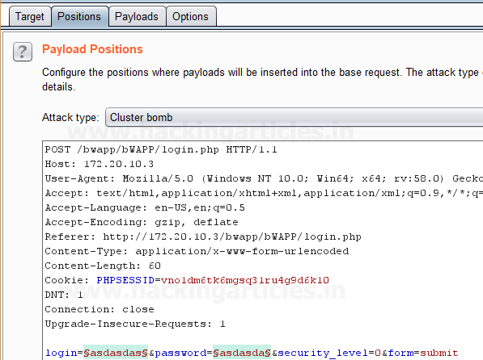

Now click on **payloads option** after selecting payload position, here we need to add a dictionary which will use for both payload set. Then select the **Payload type** as **Simple list**for **Payload Set ‘1’**which will attack at the username field**.**

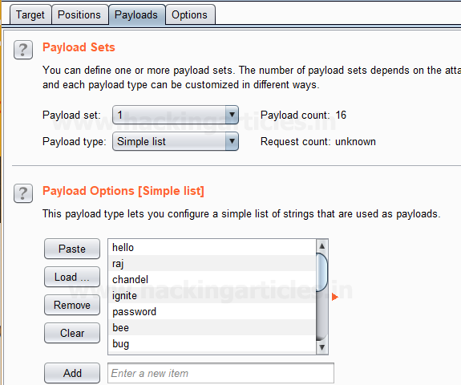

Now to attack at the password field we will select **Payload type** as **Copy other payloads**for **Payload Set ‘2’**because we want to attack the **same payload type**at payload set 2 which will **copy the dictionary** given for **payload set 1** to attack.

Select **Start Attack** in the **Intruder menu** as shown in the image.

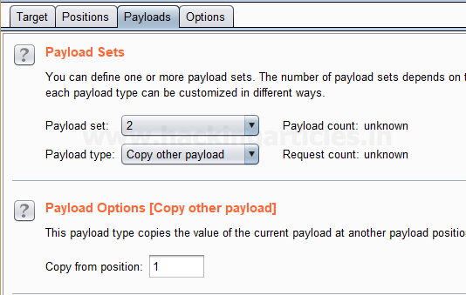

Sit back and relax because now the burp suite will do its work, match the username and password which will give you the correct username and password. The moment it will find the correct value, it will change the value of length as shown in the image.

And to confirm the password matched, you can give the matched password in the**BWAPP LAB login page**.

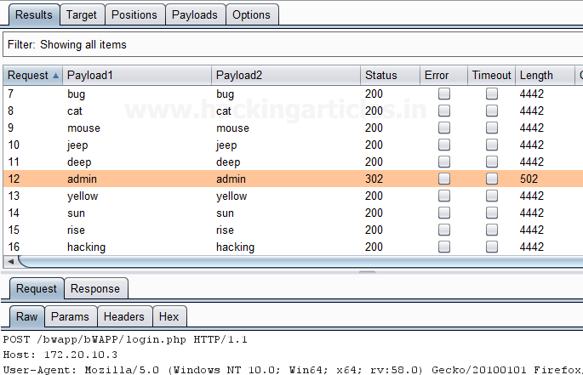

### ****Username Generator****

This type of payload allows you to set up a list of names or email addresses and can produce usernames from given specific schemes.

For example, Let’s take a username “raj chandel” which can give results in up to 115 possible usernames, some combination is as follows :

rajchandel

raj.chandel

chandelraj

chandel.raj

chandel

raj

rajc

etc…

This type of payload is useful to target at a specific user, where you do not know the username or email address scheme of the user which is being used in a specific application.

First, we have intercepted the request of the login page in the **Bwapp LAB**, where we have given wrong username and password. Then click on login, the burp suite will capture the request of the login page in the intercept tab.

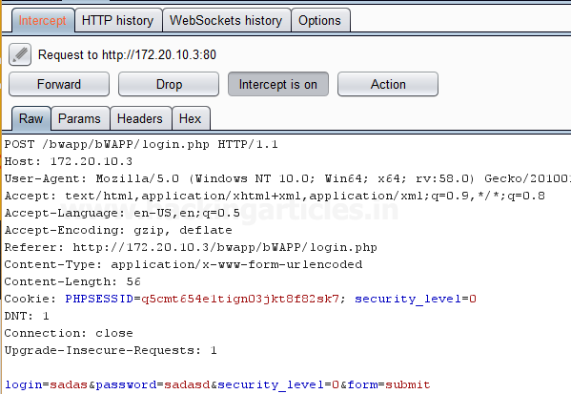

Send the captured request to the**Intruder**by clicking on the Action Tab and follow given below step. Now open the **Intruder tab**then select **Positions tab** and you can observe the highlighted username and password and follow the given below step for selecting payload position.

* Press on the **Clear button** given at right of the window frame.
* Now we will select the fields where we want to attack which is the username and password and click on **Add button.**
* Choose the **Attack type** as **Cluster Bomb.**
* In the given below image, we have selected username and password that means we will need two dictionary files i.e. one for username and second for the password.

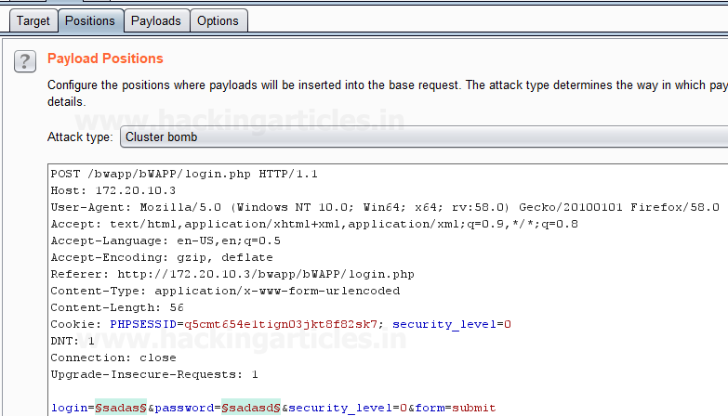

Then select the **Payload type** as “Username Generator” for **Payload Set ‘1’**which will attack at the username field, we have a given input string “raj chandel” by using the **Add option** as shown in the image, which will use different permutations on that input string given to match the correct username.

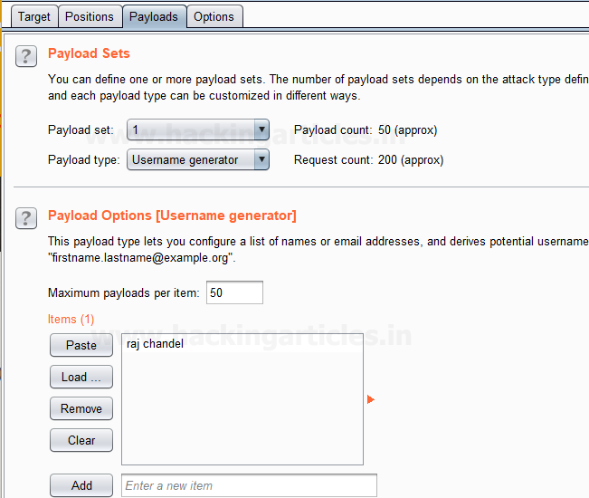

Now to attack at the password field we will select **Payload type** as **Simple list**for **Payload Set ‘2’**for which we have added a **dictionary** manually created by us by using the **Load option.**

Select **Start Attack** in the **Intruder menu** as shown in the image.

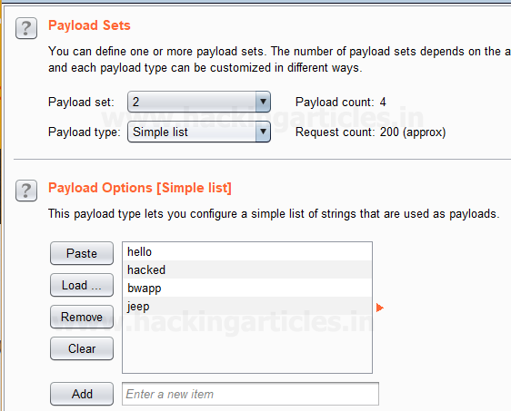

Sit back and relax because now the burp suite will do its work, match the username and password which will give you the correct username and password. The moment it will find the correct value, it will change the value of length as shown in the image.

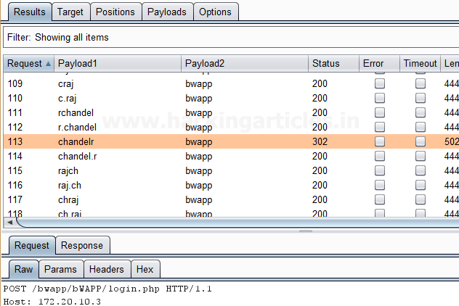

### ****Dates****

This type of payload generates date payloads within a given range and in a specified format. This type of payload is can be used in data mining or brute forcing.

For example, it can be used to guess a user’s birth date, wedding date, anniversary date etc which can be used to brute force the security questions for an application or web applications, or it can use to brute force the password of user’s, where the user uses dates as their password.

The following options are available in this type of payload:

* **From** – This is said as the first date which will be generated.
* **To** – This is said as the last date which will be generated.
* **Step** – This is said as an increase between sequential dates, days, weeks, months or years. It should be a positive value.
* **Format** – This is said as the format in which dates can be represented. we can select from different predefined date formats, or we can make our own custom date format as per our requirement. Some example of the date format is given below:

|  |  |
| --- | --- |
| E | Mon |
| EEEE | Monday |
| D | 2 |
| dd | 02 |
| M | 9 |
| MM | 09 |

Repeat the same to intercept the request of the login page in the **Bwapp LAB**, where we have given wrong username and password. Then click on login, the burp suite will capture the request of the login page in the intercept tab.

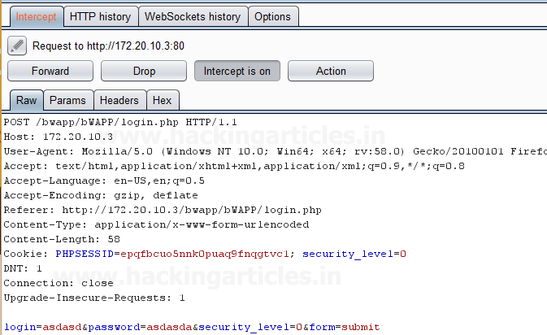

Send the captured request to the**Intruder**by clicking on the Action Tab and follow given below step. Now open the **Intruder tab**then select **Positions tab** and you can observe the highlighted username and password and follow the given below step for selecting payload position.

* Press on the **Clear button** given at right of the window frame.
* Now we will select the fields where we want to attack which is the username and password and click on **Add button.**
* Choose the **Attack type** as **Cluster Bomb.**
* In the given below image, we have selected username and password that means we will need two dictionary files i.e. one for username and second for the password.

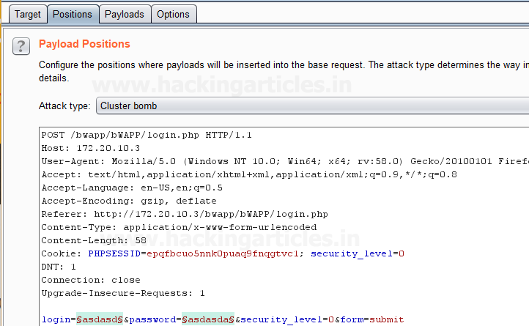

Then select the **Payload type** as **Simple list**for **Payload Set ‘1’**which will attack at the username field where we have given a dictionary as an input string as shown in given below image.

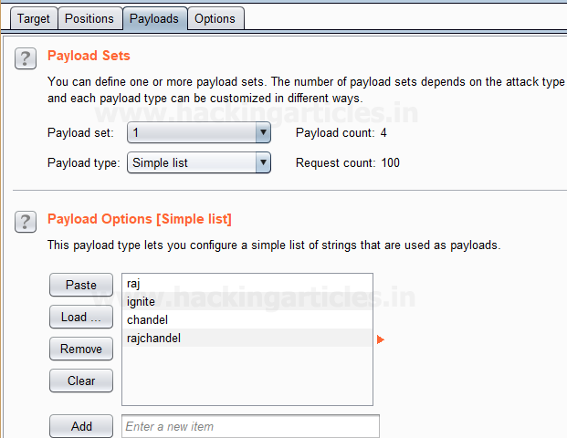

Now to attack at the password field we will select **Payload type** as **Dates**for **Payload Set ‘2’** because we are guessing the user might have its **birth date**or **any other date** as a password**.**

After this, we have set the inputs for **Payload set ‘2’** in the fields given in the payload options such as **FROM, TO, STEP and FORMAT** as shown in the image.

Now Select **Start Attack** in the **Intruder menu**for brute force attack.

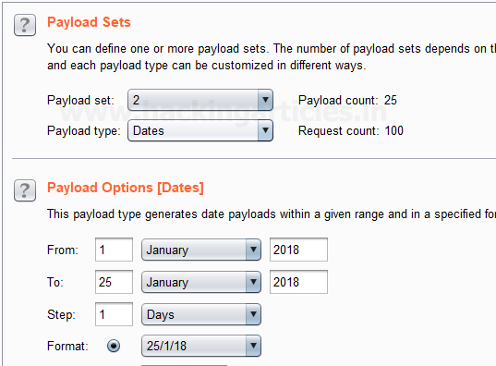

Sit back and relax because now the burp suite will do its work, match the username and password which will give you the correct username and password. The moment it will find the correct value, it will change the value of length as shown in the image.

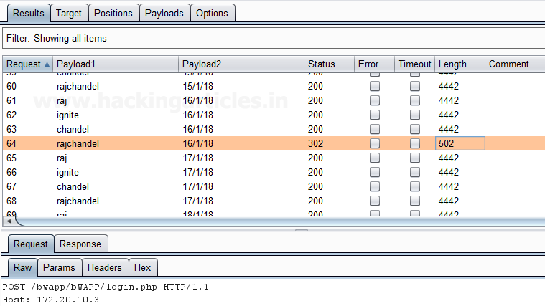

# Burpsuite Encoder & Decoder Tutorial

[January 24, 2018](https://www.hackingarticles.in/burpsuite-encoder-decoder-tutorial/) By [Raj Chandel](https://www.hackingarticles.in/author/raaj/)

Burpsuite Decoder can be said as a tool which is used for transforming encoded data into its real form, or for transforming raw data into various encoded and hashed forms. This tool is capable of recognizing several encoding formats using defined techniques. Encoding is the process of putting a sequence of character’s (letters, numbers, punctuation, and symbols) into a specialized format which is used for efficient transmission or storage. Decoding is the opposite process of encoding the conversion of an encoded format back into the original format. Encoding and decoding can be used in data communications, networking, and storage.

Today we are discussing the **Decoder** Option of ‘Burp Suite’. Burp Suite is a tool which is used for testing Web application security. Its various tools work seamlessly together to support the entire testing process, from initial mapping and analysis of an application’s attack surface, through to finding and exploiting security vulnerabilities. This tool is written in JAVA and is developed by PortSwigger Security.

There are 9 types of decoder format in Burp Suite:

* **Plain text**
* **URL**
* **HTML**
* **Base64**
* **ASCII Hex**
* **Hex**
* **Octal**
* **Binary**
* **Gzip**

### ****URL Encoder & Decoder****

When you will explore decoder option in burp suite you will observe two sections left and right. The left section is further divided into two and three sections for encoding and decode option respectively. The right section contains the function tab for encoding and decodes option. And if you will observe given below image you can notice there are two radio buttons for selecting the type of content you want to encode or decode.

Enable the radio button for text option and then we can give any input in the box to be encoded, here we have given **Raj chandel** as an input as shown in the image. After that click on the **Encoded as** an option and select **URL field** from given list as shown in the image. We will get the **encoded result** in **URL format** in the second box as shown in the image.

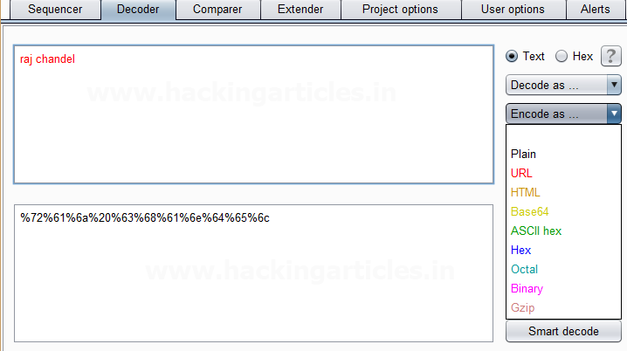

 We can directly decode the **Encoded URL Text** by clicking on the **Decoded as** an option and selecting **the URL field** from the given list of options as shown in the image.  This will **decode** the **encoded URL text**into **plain text** in the third box as shown in the image.

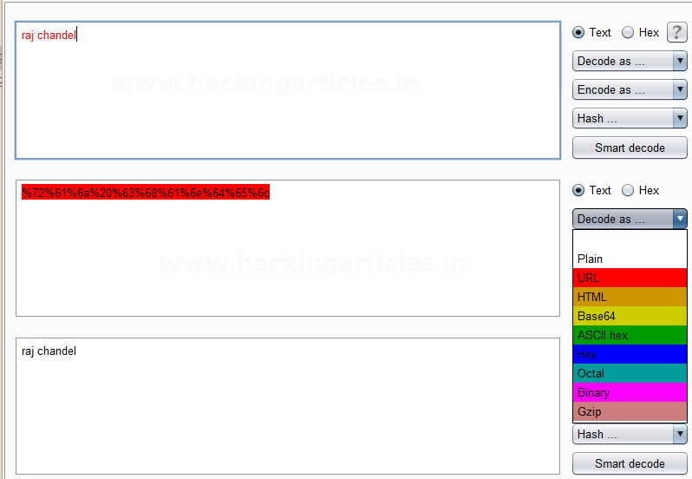

### ****HTML Encoder & Decoder****

Repeat the same and give any input in the first box to be encoded, here we have given **Raj chandel** as an input as shown in the image. After that click on the **Encoded as** an option and select **HTML field** as shown in the image. We will get the **encoded result** in **HTML format** in the second box as shown in the image.

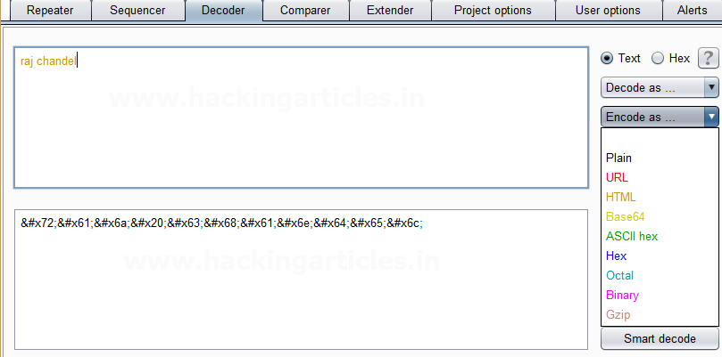

We can directly decode the **Encoded HTML Text** by clicking on the **Decoded as** an option and selecting **the HTML field** as shown in the image.  This will **decode** the **encoded HTML text**into **plain text** in the third box as shown in the image.

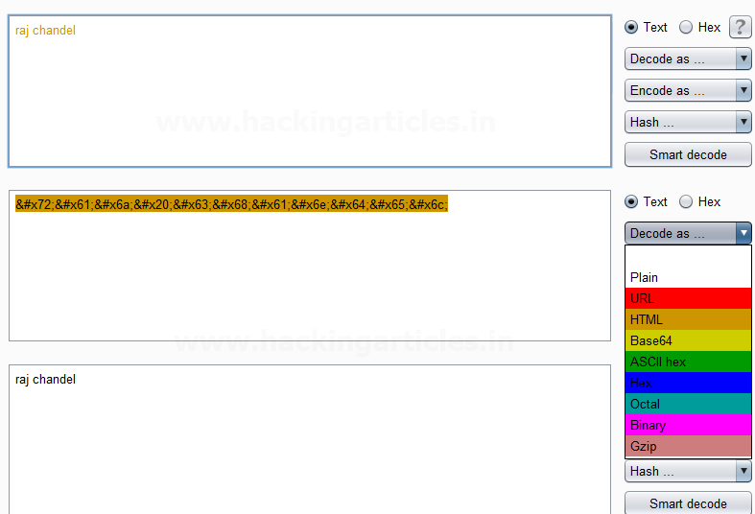

### ****Base64 Encoder & Decoder****

Repeat the same process and give any input in the first box to be encoded, here we have given **Raj chandel** as an input as shown in the image. After that click on the **Encoded as** an option and select **Base64 field** as shown in the image. We will get the **encoded result** in **Base64 format** in the second box as shown in the image.

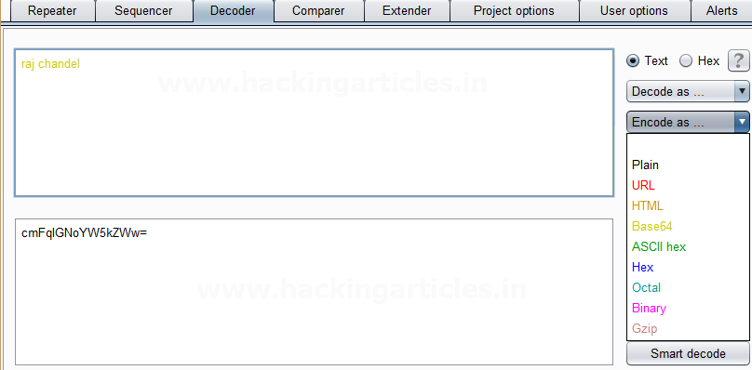

We can directly decode the **Encoded Base64 Text** by clicking on the **Decoded as** an option and selecting **the Base64 field** as shown in the image.  This will **decode** the **encoded Base64 text**into **plain text** in the third box as shown in the image.

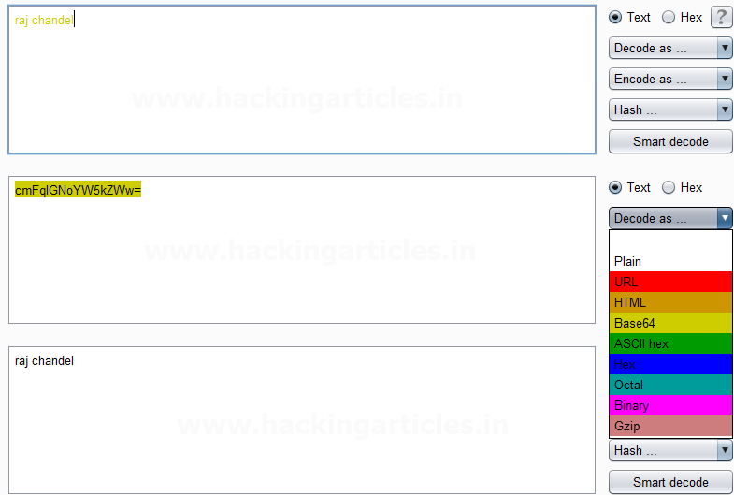

### ****ASCII Hex Encoder & Decoder****

Again repeat the same process and give any input in the first box to be encoded, here we have given **Raj chandel** as an input as shown in the image. After that click on the **Encoded as** an option and select **ASCII Hex field** as shown in the image. We will get the **encoded result** in **ASCII Hex format** in the second box as shown in the image.

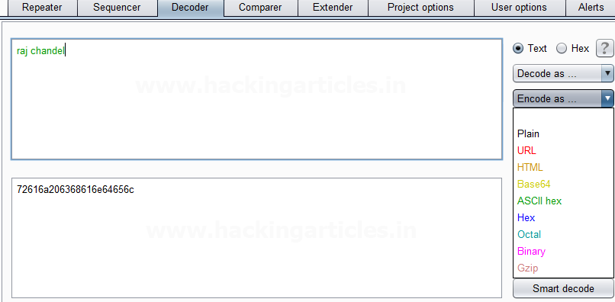

We can directly decode the **Encoded ASCII Hex Text** by clicking on the **Decoded as** the option and selecting **ASCII Hex field** as shown in the image.  This will **decode** the **encoded ASCII Hex text**into **plain text** in the third box as shown in the image.

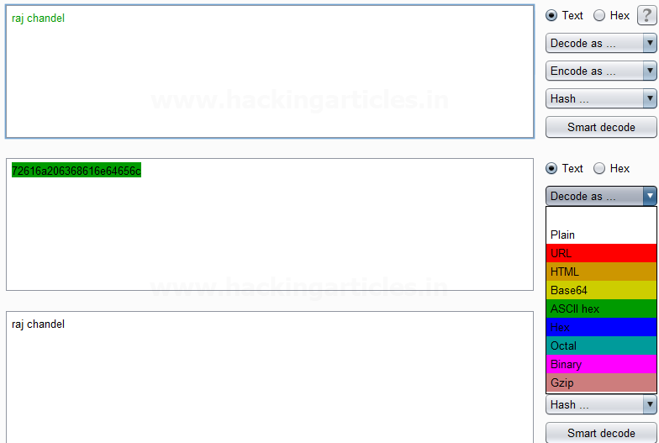

### ****Hex Encoder & Decoder****

Repeat same as above and give any input in the first box to be encoded, here we have given **Raj chandel** **123456789** as an input as shown in the image. After that click on the **Encoded as** the option and select **Hex option**as shown in the image. We will get the **encoded result** in**Hex format** in the second box as shown in the image.

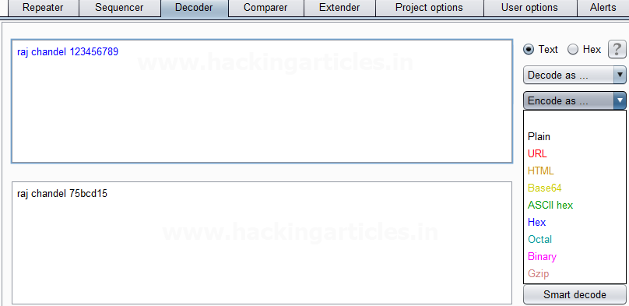

We can directly decode the **Encoded Hex Text** by clicking on the **Decoded as** the option and selecting the**Hex field** as shown in the image. This will **decode** the **encoded Hex text**into **plain text** in the third box as shown in the image.

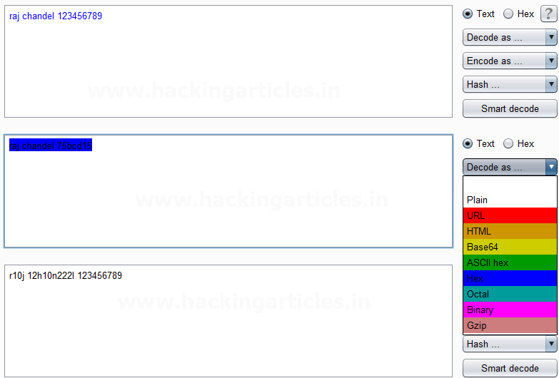

### ****Octal Encoder & Decoder****

Repeat again and give any input in the first box to be encoded, here we have given **Raj chandel** **123456789** as an input as shown in the image. After that click on the **Encoded as** an option and select **Octal field** as shown in the image. We will get the **encoded result** in**Octal format** in the second box as shown in the image.

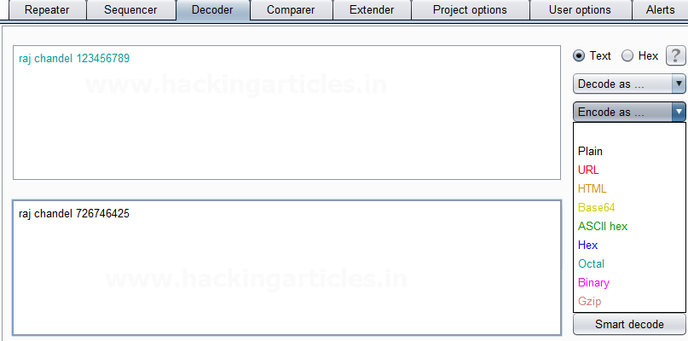

We can directly decode the **Encoded Octal Text** by clicking on the **Decoded as** the option and selecting the**Octal field** as shown in the image.  This will **decode** the **encoded Octal text**into **plain text** in the third box as shown in the image.

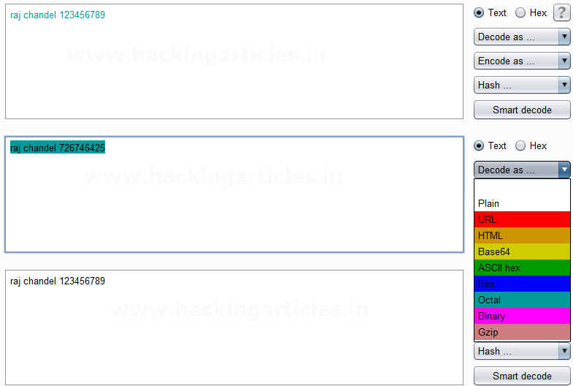

### ****Binary Encoder & Decoder****

Repeat the same and give any input in the first box to be encoded, here we have given **Raj chandel** **123456789** as an input as shown in the image. After that click on the **Encoded**as an option and select **Binary field** as shown in the image. We will get the **encoded result** in**Binary format** in the second box as shown in the image.

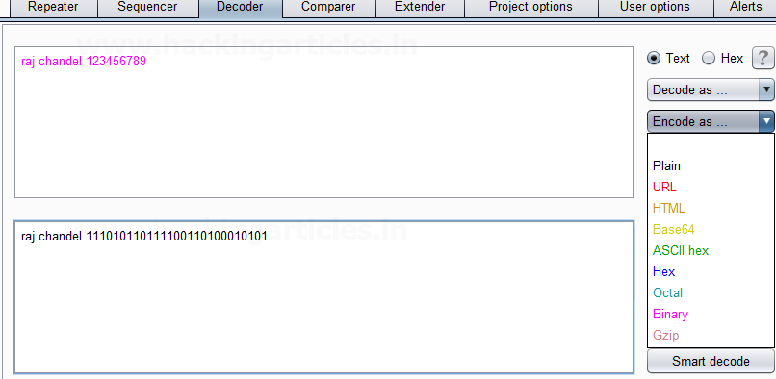

We can directly decode the **Encoded Binary Text** by clicking on the **Decoded as** an option and selecting**the Binary field** as shown in the image.  This will **decode** the **encoded Binary text**into **plain text** in the third box as shown in the image.

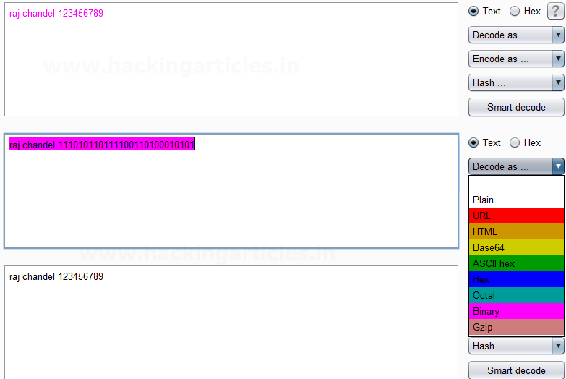

### ****Gzip Encoder & Decoder****

Give any input in the first box to be encoded, here we have given **Raj chandel** as an input as shown in the image. After that click on the **Encoded as** an option and select **Gzip field** as shown in the image. We will get the **encoded result** in **Gzip format** in the second box as shown in the image.

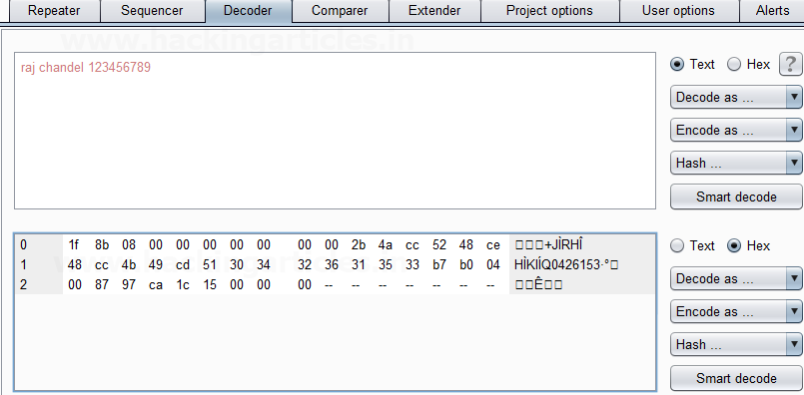

We can directly decode the **Encoded Gzip Text** by clicking on the **Decoded as** an option and selecting **the Gzip field** as shown in the image.  This will **decode** the **encoded Gzip text**into **plain text** in the third box as shown in the image.

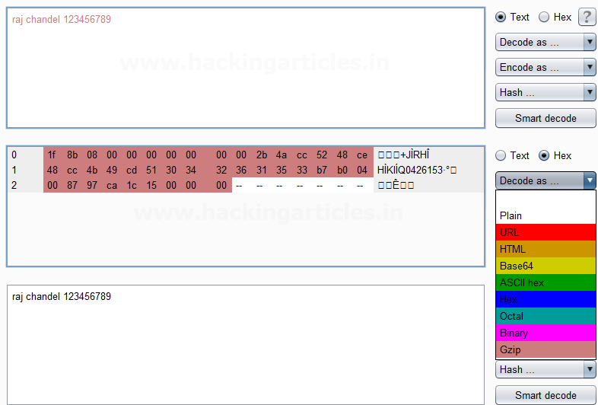

# Burp Suite for Pentester: Active Scan++

[January 6, 2021](https://www.hackingarticles.in/burp-suite-for-pentester-active-scan/) By [Raj Chandel](https://www.hackingarticles.in/author/raaj/)

Using Burp Suite as an automated scanner? Wondering right, even some pentesters do not prefer it, due to the fewer issues or the vulnerabilities it carries within. But what, if the burp scanner itself could identify the least common vulnerabilities along with core findings.

So, today in this article we’ll explore one of the most popular burp plugins **“Active Scan++”**which thereby merges up with the burp’s scanner engine in order to enhance its scanning capabilities to identify the additional issues within an application.

### ****Table of Content****

* Exploring & Initializing Active Scan++
* Enhancing the Audit functionalities
  + Audit the application
  + Auditing specific Injection Points

### ****Exploring & Initializing Active Scan++****

Advanced vulnerabilities require advanced scanning techniques.

Thereby, Active Scan++ one of the most of most popular burp’s extension designed for the **Burp’s Professional users** by **“James Kettle”**in order to improvise the burp’s active and passive scanning capabilities.

However, this plugin gets integrated within the burp scanner such that it could help in the issue discovering part for the **Host Header Attacks, Password Reset Poisoning, Cache Poisoning, DNS Rebinding, XML Injection, Arbitrary Header Injection, Template Injeciton, Blind Code Injection** and the list goes on.

Moreover, this plugin also identifies the insertion points for **HTTP** **Basic Authentication.**

Being so much effective, so let’s find it out at the **bApp**store first. And we know where to navigate for that. Over at the **Extender**section, switch to the **bApp store**and then you’ll find this tool at the top with the highest rating.

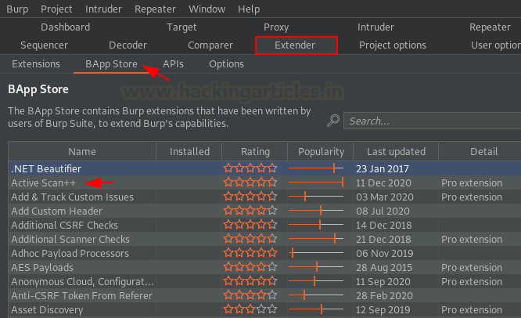

Let’s now switch to the left panel in order to identify the **Install**button. But wait !! It requires Jython, so let’s install and configure that first.

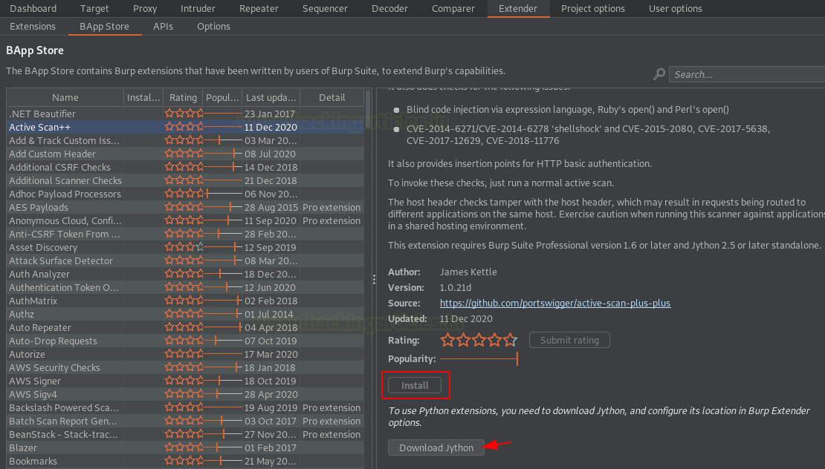

Head to Jython’s official website, download the **Standalone** **Jython’s** file.

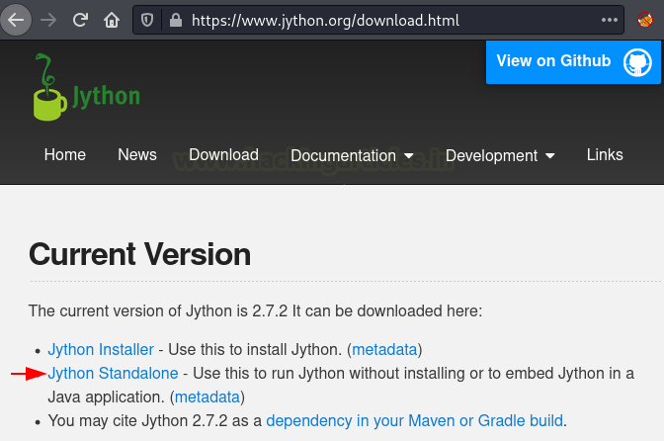

As soon as the file got stored up over at the local machine, we’ll embed it with our Burp Suite application. Back at the extender tab, navigate to the **Options**section there and scroll down for the **“Python Environment”,**hit the **select file** button, and then opt for the downloaded file.

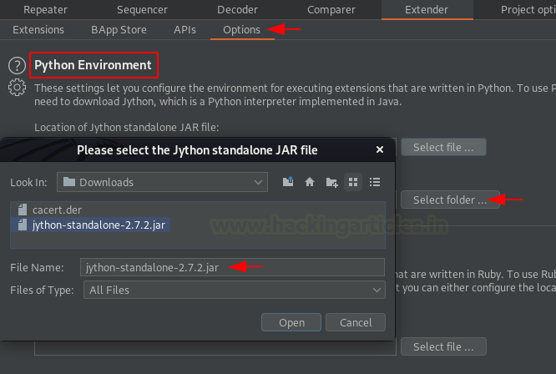

Once done with all this, you’ll have your screen somewhat similar to the below image. But, the Jython’s configuration is yet not over, **restart your burp** in order to get the changes reflected.

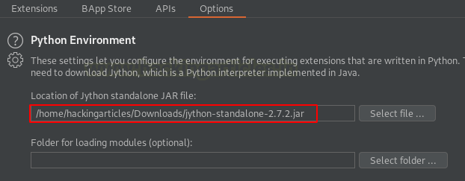

Now head back to the bApp store and open the **Active Scan++**righ-side portal. From the below image you can see that the **Install**button is now active, let’s fire it to initiate the installation.

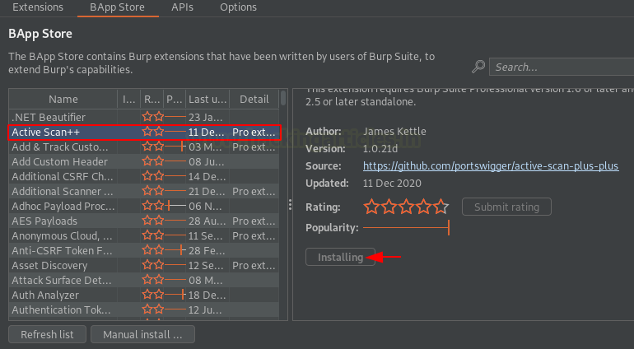

Great!! We got the **Reinstall** button, seems like the extension had been set up successfully.

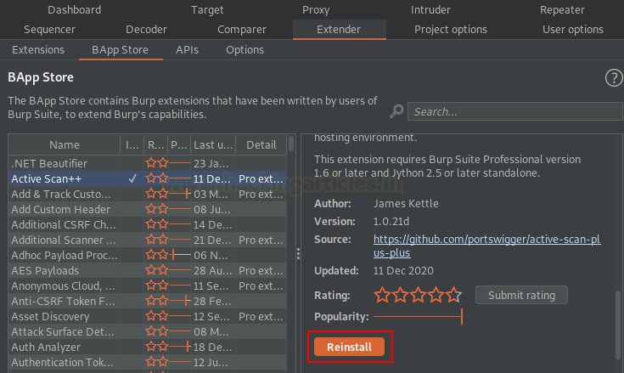

### ****Enhancing the Audit Functionalities****

You might be wondering, like being the most popular, Active Scan++ should have its own place at the top panel, so where it is?

As discussed earlier that **Active Scan++ integrates with the burp’s scanner** such in order to assist it to identify additional vulnerabilities. Thereby, we do not have any specific location to find it. However, we can analyze its working while performing an active or passive scan.

So, let’s see what additional it dumps out when we initiate a scan over at the entire application.

**Audit the application**

Turn **On**the Browser’s **Proxy Service**and then surf the OWASP’s Mutillidae vulnerable application.

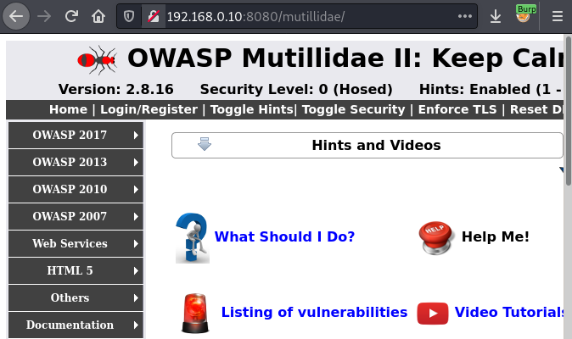

Now, let’s navigate to the **Target** option over at our burp suite monitor, further head to the **Site map**.

The Left panel carries up the web application’s hierarchy, let’s opt the **root branch**, and then we’ll hit a right-click to opt **“Actively scan this branch”**such in order to share the application for the scanning part.

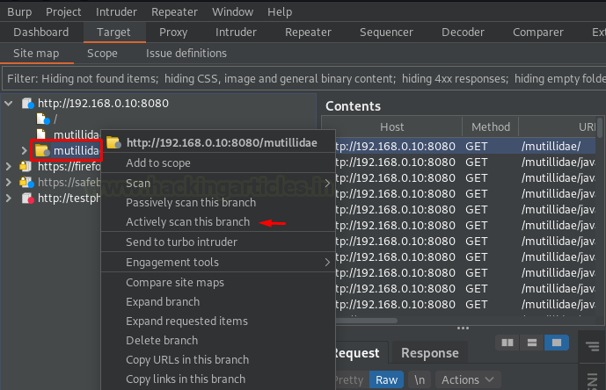

As soon as do so, we got our auditing task aligned at the **“Dashboard”.**

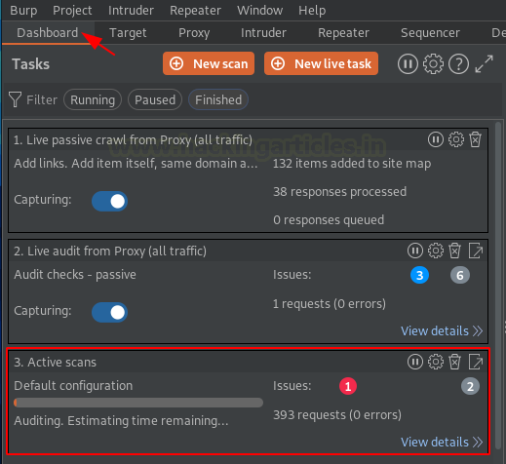

And within a few minutes, you can see a number of issues segregated at the right panel, let’s check them out.

You might find most of the issues discovered with the burp’s scanner but there are some like cache poisoning, DNS rebinding, Host header Injection, all these additional ones are identified with the Active Scan++.

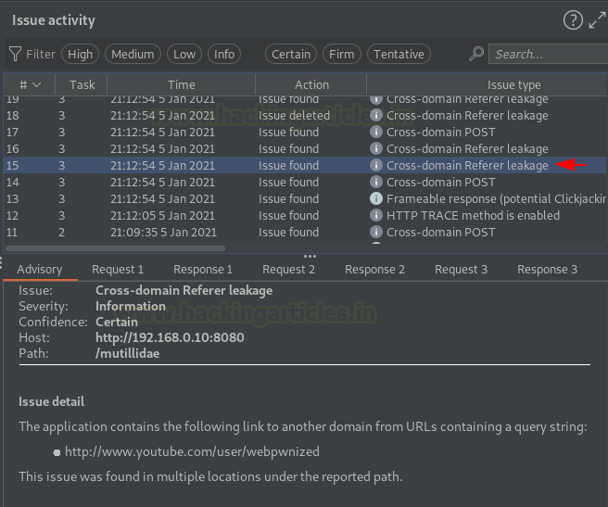

**Auditing specific Injection Points**

What if, you don’t want to test the entire application’s branch neither a specific web-page, but you want an injection point to be audited and if it’s possible then does **Active Scan++**still collaborates with the burp scanner?

As soon as we hit the install button at the bApp store, the very first-second Active Scan++ got bounded with the Burp’s Scanner. So, whether it’s about auditing the entire application or a specific injection point, the Active Scan++ is always involved within it.

And about the Injection point auditing, so let’s do that.

Initiate the bWAPP application with **bee: bug**and then navigate to the **HTML Injection (Reflected)** webpage. Further, we’ll enter some test credentials and hit the **Go**button with our **Proxy Service**turned  **“ON”**

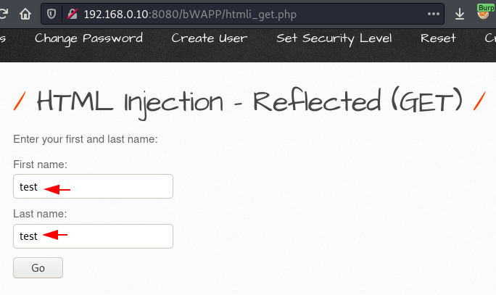

Over at our burp suite monitor, we got the ongoing HTTP request captured, let’s share it with the intruder.

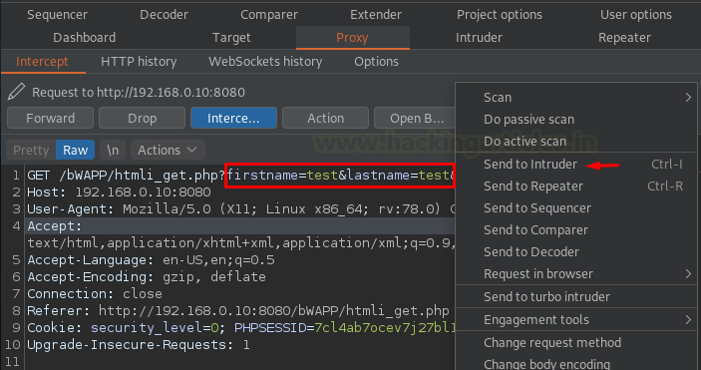

Once done, let’s navigate to the **Position section**over at the intruder tab in order to set the injection point. Simply clear the default selections and add the one you want the scanner to audit.

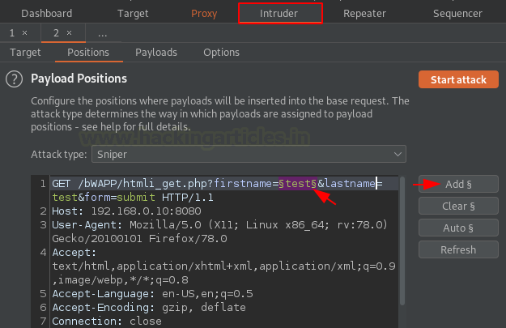

What now? A simple right-click is always our helping hand. So, let’s hit the mouse right button and then opt **“Scan defined insertion points”.**

As we haven’t deleted our previous task, thereby the burp drops two option either to send this request with the ongoing Audit or to start a new one for this.

Let’s hit the **Open Scan launcher**in order to start and customize the new scan.

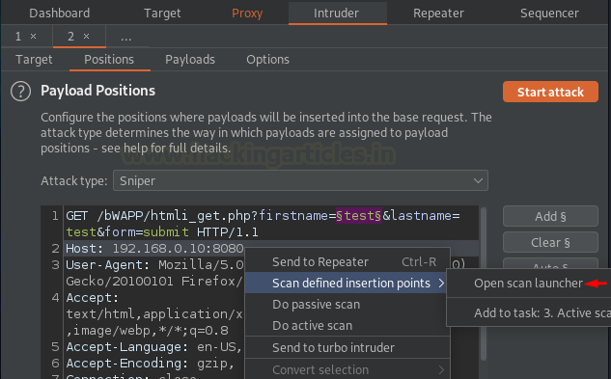

As soon as we do so, we got a window that popped up in front of us stating **“New Scan”**. Let’s move forward with the default configuration by hitting the **OK**button. Check our [previous article](https://www.hackingarticles.in/burp-suite-for-pentester-web-scanner-crawler/) if you want to customize your scanner accordingly.

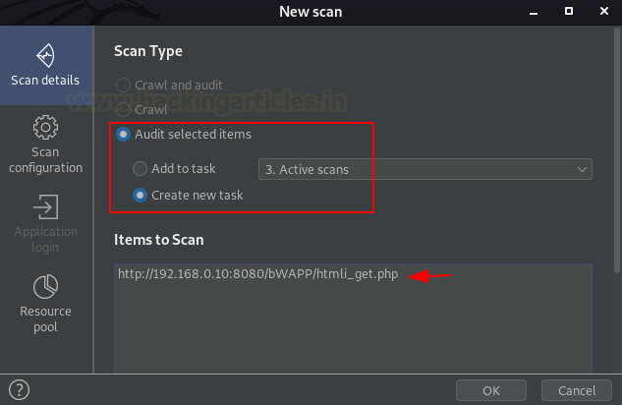

From the below image we can see that our scanner captured about **3 Basic**and**1 Critical issue**by sharing about 250+ requests at the application’s injection point.

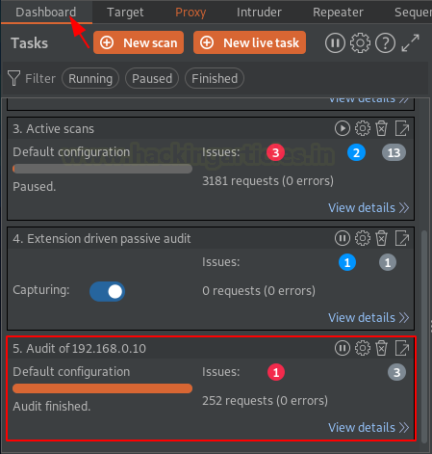

Time to analyze. From the below image, we can see that the burp scanner tested Cross-Site Scripting for our injection point and dumped the issue details with the exploiting payload and the mitigation steps.

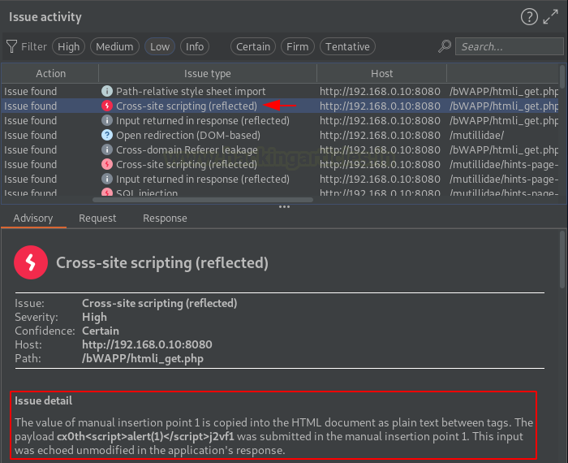

# Burp Suite for Pentester: Software Vulnerability Scanner & Retire.js

[January 9, 2021](https://www.hackingarticles.in/burp-suite-for-pentester-software-vulnerability-scanner/) By [Raj Chandel](https://www.hackingarticles.in/author/raaj/)

Not only the fronted we see or the backend we don’t, are responsible to make an application be vulnerable. A dynamic web-application carries a lot within itself, whether it’s about JavaScript libraries, third-party features, functional plugins and many more. But what, if the installed features or the plugins themselves are vulnerable?

So, today in this article we won’t be focusing on any specific vulnerability, rather we’ll follow up with some nice burp extensions that will help us to **identify the vulnerable versions of the software or the libraries installed** within an application.

### ****Table of Content****

* **Exploring the Burp Plugins**
  + **Software Vulnerability Scanner**
    - Configuring the Extension
    - Fingerprinting the installed software
    - The Vulners.com API
  + **Retire.js**
    - Setting up the plugin
    - Dumping the Outdated JavaScript Libraries

### ****Exploring the Burp Plugins****

Over in all of our previous articles whatever scanner or the plugin we’ve used, they all dump almost the same results i.e., they basically identify and guide us about the **existing vulnerabilities** majorly on the basis of the OWASP top 10.  But, what about the software or the add-ons library versions that were embedded within the application’s frameworks, how we could identify them that they are vulnerable or not.

Thereby in order to dig the web-application at its maximum depth, burp suite offers some amazing plugins that **scans the embedded software and the add-on libraries** and then further drop out the one that have the **outdated version** or their **versions are vulnerable** to some specific exploits.

So, let’s explore the two most popular extensions, one that checks the version from its exploits database and the other simply checks for the outdated JavaScript libraries.

### ****Software Vulnerability Scanner****

Have you ever surfed [**vulners.com**](https://vulners.com/) to identify the vulnerabilities founded by the different security researchers?

Not yet, then over with this extension, you’ll get a better understanding of the **vulners.com exploit’s database** or its scanning **API keys** and the other features that the web-application carries within.

So, let’s initiate by exploring, **what this burp extension is?**

The Software Vulnerability Scanner is one of the most popular burp extensions that scans the application in order to determine vulnerabilities in the software versions using the vulners.com API.

But **how this plugin detects the vulnerable software versions**?

In order to do so, this plugin follows either of the two –

1. It identifies the vulnerable software with the fingerprints or the CPE (Common Platform Enumeration).
2. It checks the vulnerable paths with the database and identifies whether any exploit can be used against that path or not.

Pretty complex scenarios, right!! Follow up with the article and you’ll find them the simplest.

**Configuring the Extension**

Let’s install the plugin by navigating to the **BApp Store** at the **Extender tab**and there we’ll try to find **Software Vulnerability Scanner.**

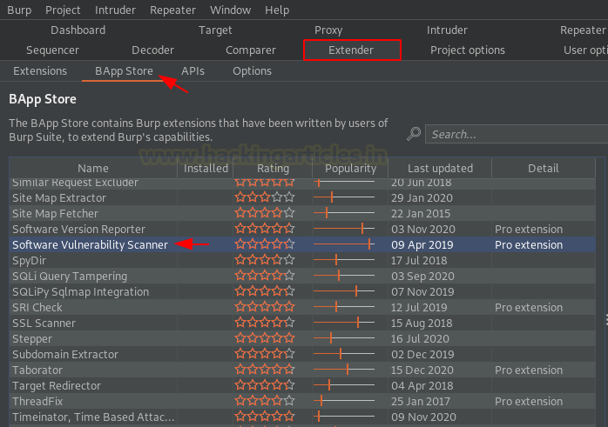

As soon as we find that, we’ll tune over to the right section and will hit the **Install button** to make it a part of the Burp Scanner.

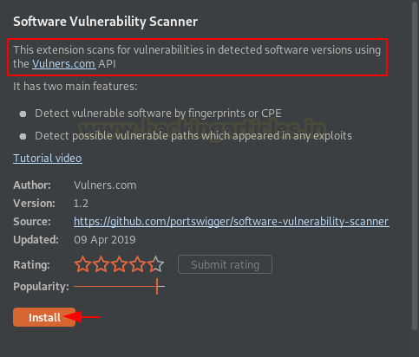

And within a few minutes, we’ll get its tab positioned into the top panel as **“Software Vulnerability Scanner”,**let’s explore if first.

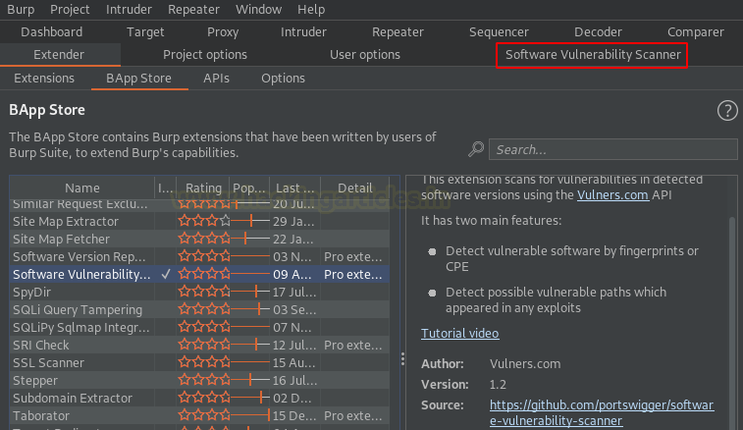

Navigating to the plugin’s window, over at the **Scan Rules tab**, we’re having two segregated sections one for the **API** and other for the **Scan Rules.**However, the rule book for the scanning part had been loaded by default, thereby we just need to set the API key.

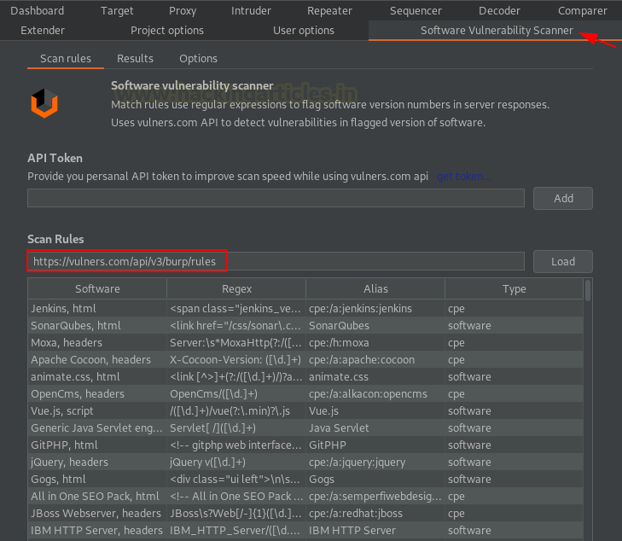

Although this plugin is good to go without the API key value, there it will simply try to match the vulnerable path with the database. But if you want to embed your own key, you can hit the **get token..** section and **register for an API key** for free.

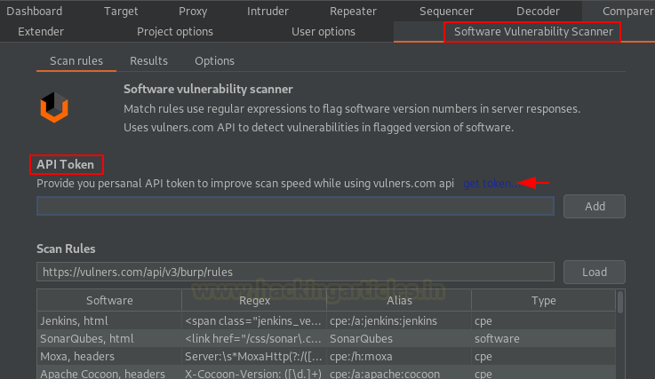

As soon as we hit the button, we got redirected to the vulners.com user info page. Login and fill the input fields to generate the API key.

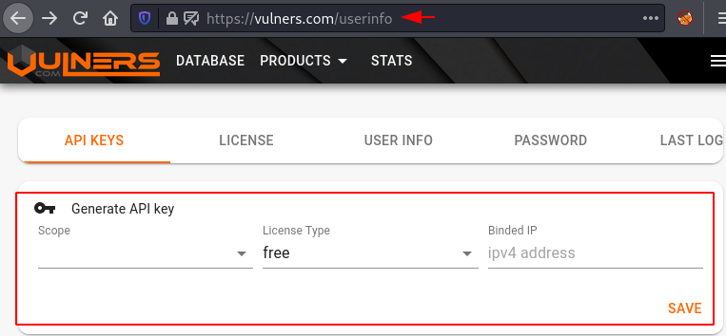

However, for this section, we’ll be working without the API key. But we’ll enhance its scanning capabilities by **customizing it** over into the **options** **tab**.

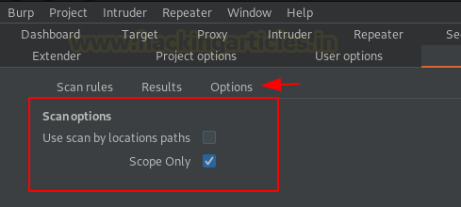

Let’s unflag the checkbox of **Scope Only** and hit the **Use scan by location paths**option. Although flagging this feature might give us some **false positives** as it will take keywords from the vulnerable application and then match them with the keywords present at the vulners.com’s database.

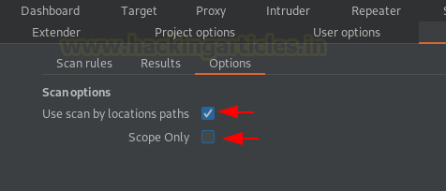

**Fingerprinting the installed software**

Once done with the configuration, we’ll thus **turn our browser’s proxy**and will surf **testphp.vulnweb.com.**As soon as the web-page boots up, we’ll roam around in order to generate some traffic.

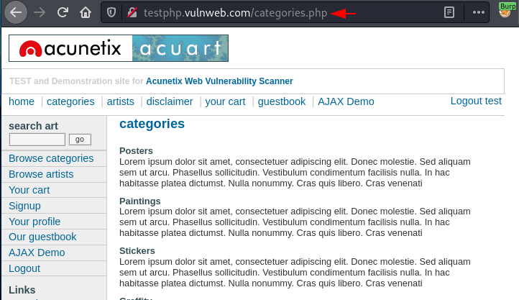

Enough roaming!! Let’s get back to our burp suite monitor and will switch to the **dashboard** tab there. From the below image, we can see that the burp scanner was on  **Live Audit**, i.e. whatever we did or surfed, it got captured and was shared with the burp scanner.

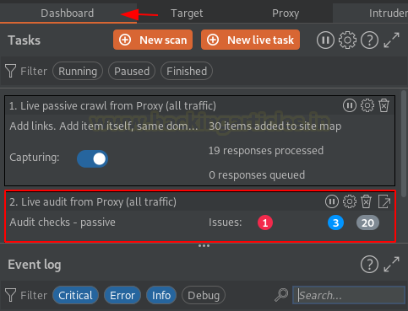

But what about the **Issue Activities,**let’s explore it and check what it is having for us.

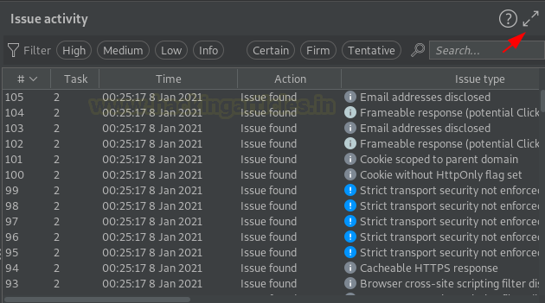

As soon as the extend window opens, we’ll sort its contents with the **Issue type**. From the below image we can see that the scanner found something stating **“[vulners] possible vulnerable path found”.**Seems like our configuration is working perfectly.

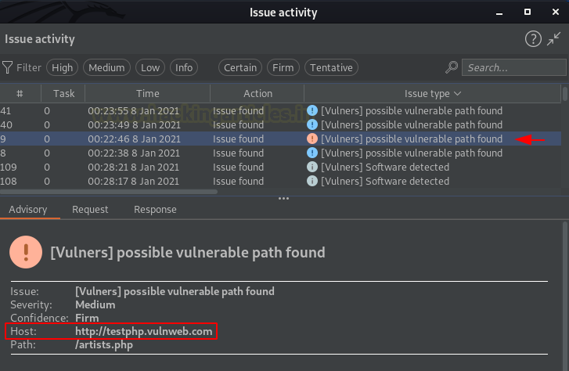

Let’s explore this issue a bit deeper, carrying up from the **Issue details**, it dumps about a number of **exploits that uses the same path** and are into the vulners database.

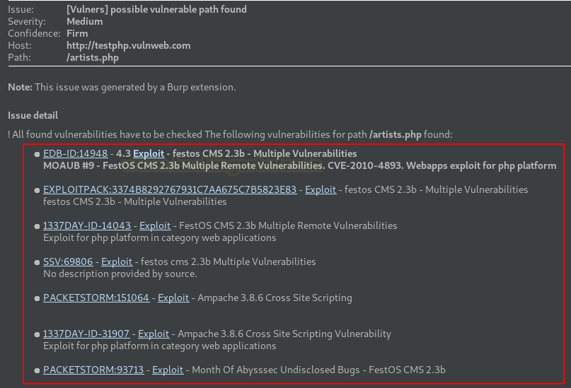

Let’s check the **PacketStrom** by hitting the **“Exploit”**button aligned with that. And as soon as we do so, we got redirected to the **vulners.com**website with the exploit data over it.

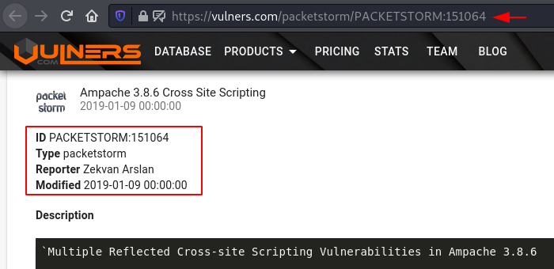

As we tried to search **artisits.php,**we got the path value similar to the one we had over at testphp.vulnweb.com.

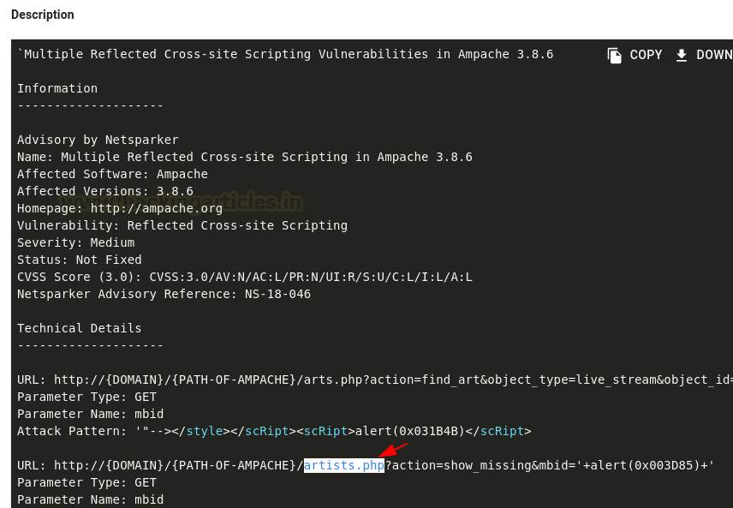

However, you can analyze the other listed exploits too much in order to have a better understanding of how vulnerable the software version could be.

Once done, we’ll further move back to the **Software Vulnerability Scanner**tab at our burpsuite and will switch to the **Results** section there, which contains the **vulnerable software versions aligned with their names and hosts** and the**Possible vulnerable software uses specific paths**.

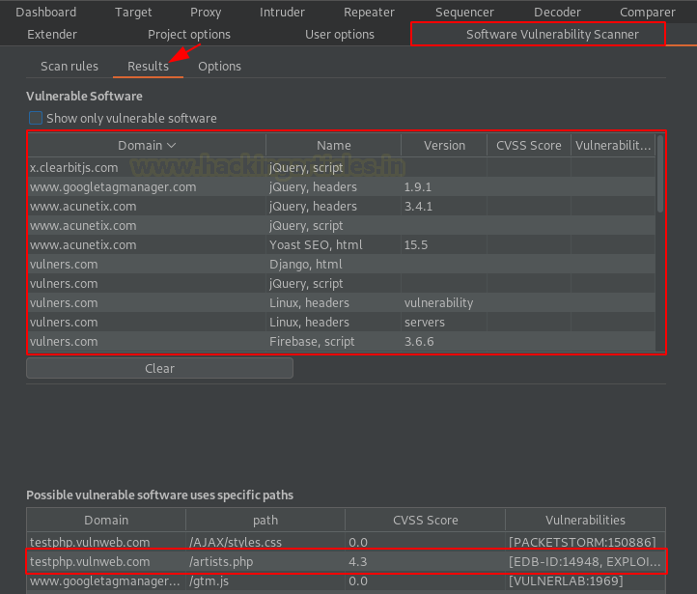

### ****Retire.js****

Dynamic web-application carries a number of libraries within themselves whether it’s React, Angular or JQuery, but what about their analysis part like how we could identify that the application we’re testing is having the outdated version of the JavaScript packages or not.

Thereby for the analysis part, we’re having one more amazing burp plugin i.e. **Retire.js,**its name itself reveals its work as **“Retire JavaScript”**i.e. it identifies the retired or the outdated versions (vulnerable) of javascript libraries that application is using.

Before involving more into the theory section, let’s jump directly to its installation. However, you can learn more about it from [**here**](https://retirejs.github.io/retire.js/)

**Setting up the Plugin**

Back into the bApp store and we’ll search for the keyword **“R”,**and there the one with the highest popularity bar is our plugin.

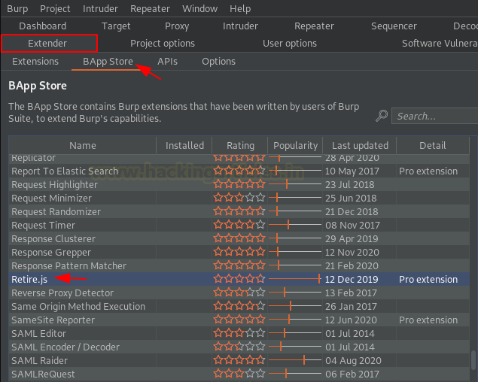

However, due to its popularity and its reviews Burp Suite had made it available only for the **Professional Edition** users. So let’s hit the **Install button**at the right-side and initiate the installation.

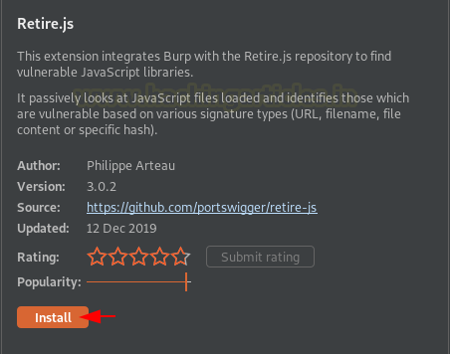

Once done with the installation part, let’s check it over in the top panel. But wait !! Where it is?

Similar to Active scan++,  as soon as the plugin got downloaded, it got embed up with the Burp Scanner, but we can check its existence by switching to the **Extensions section**at the **Extender tab.**

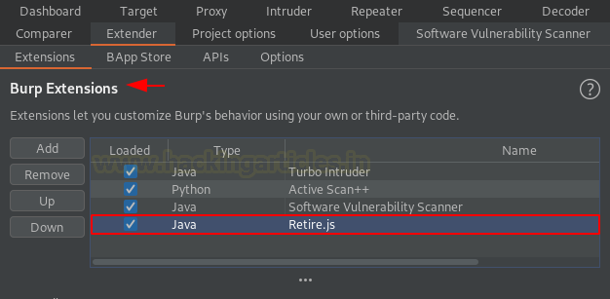

**Dumping the Outdated JavaScript Libraries**

Once the plugin got configured, we just need to initiate the scanner and within a few minutes, we’ll get the output. But in order to capture a clearer result, let’s disable the other scanner plugins and we’ll only flag **Retire.js**

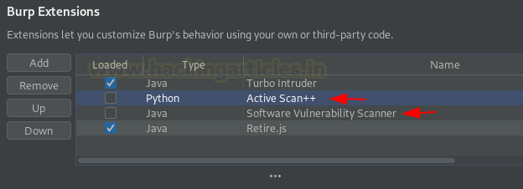

Time to surf a vulnerable application. So, for time being, let’s make it the **OWASP Juice Shop** and we’ll bypass the application’s login with **‘ OR ‘1’=’1’ ;**

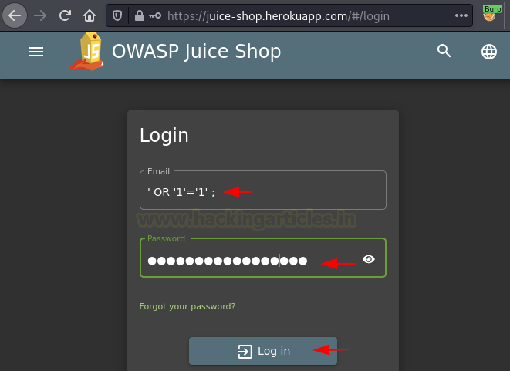

As we did at the testphp.vulnweb.com, we’ll do the same here. Yes, **surf the website** with the **browser proxy ON** to generate traffic.

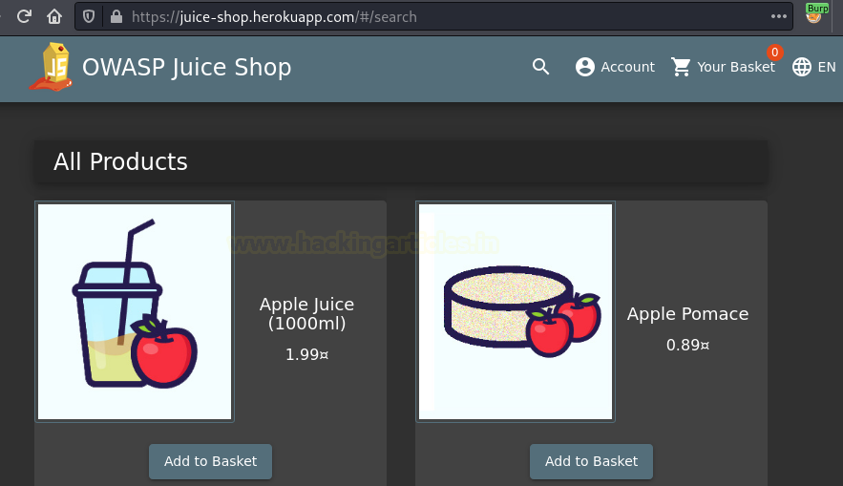

After a few page visits, let’s move back to the burp suite dashboard and will check the **Tasks tab**there.

From the below image, you can see that we got about **32 Requests** in the **Live Proxy Audit.**

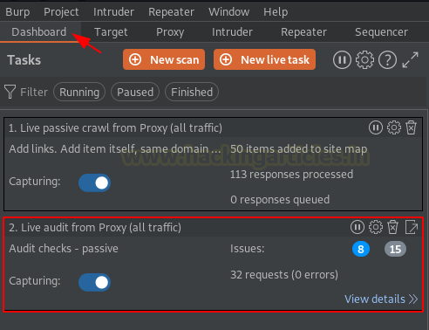

Let’s check them out in the **Issue Activity tab.**Sorting the contents as per the **Issue Type** we for the jquery vulnerabilities lined up there.

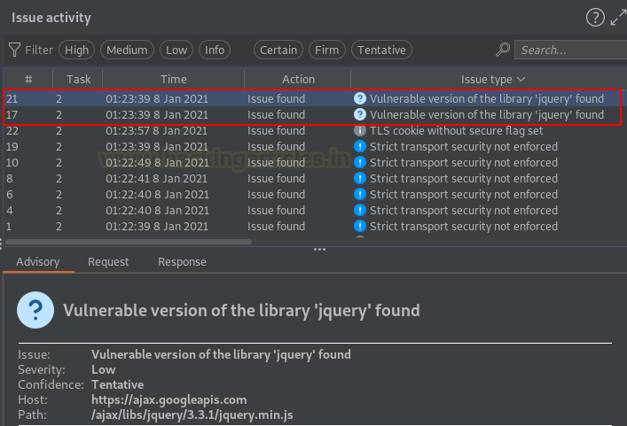

Turning to the **Advisory**section, we can see that Retire.js has **dumped a vulnerable jquery library**that was used over profile web-page of the application. However, we can search the exploitation of this jquery library on **google**and then we’re good to go.

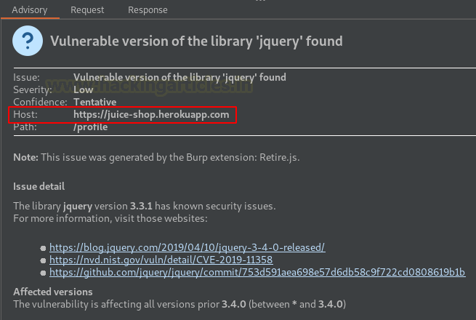

At last, let’s check the **Response tab** to analyze how the plugin detected the vulnerable jquery version. So, from the below image, you can see that as soon as we hit the **right-arrow button**, we got the vulnerable version highlighted there, as the developer didn’t notice about that the jquery version is passing over with the HTML code.

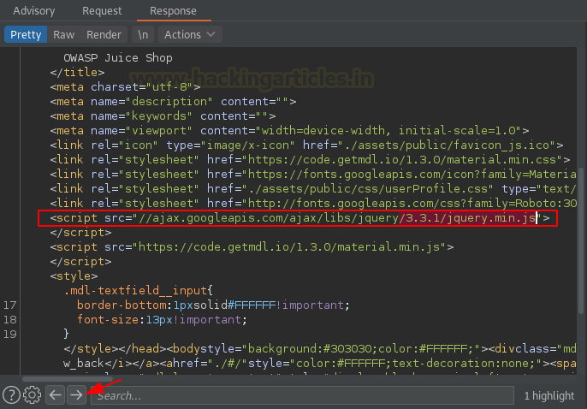

# Burp Suite for Pentester: Burp’s Project Management

[January 11, 2021](https://www.hackingarticles.in/burp-suite-for-pentester-burps-project-management/) By [Raj Chandel](https://www.hackingarticles.in/author/raaj/)

A Burp project is basically a file over where we store and organize our work for a specific test. But what if you’re working on a particular application and you might take days to test that?

Today, in this article, we’ll focus on the **project types and the options** featured by the burp suite professional version, that will help the pentester to save an incomplete test or resume it by loading the project file either with the default burp project options or by importing the customized ones.

### ****Table of Content****

* Initiating with the Project Files
  + Temporary Project
  + Project on Disk
  + Open Existing Project
* Manipulating Project Files
* Playing with Project Options
  + Exporting the customized options
  + Importing options into new projects

### ****Initiating with the Project Files****

Let’s initiate things up by **turning ON**our burp suite application. But wait, with the turn ON, we didn’t mean to reach the dashboard. We’ll simply stop when we would have the **burp’s first look,**and it is the project widget on startup.

Over at the startup panel, there are several sections within the radio buttons, let’s explore them in detail.

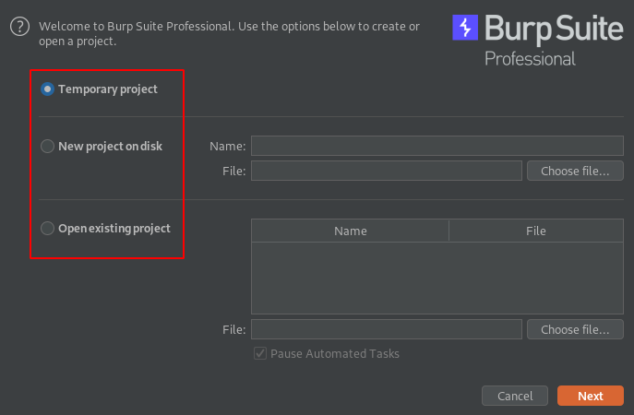

**Temporary project**

You might have used the temporary project over the majority of the time when you launch the burp application as it is **idle for** **quick tasks** and helps you to set things faster. So, let’s reach the dashboard panel once again with the **Temporary project**aligned.

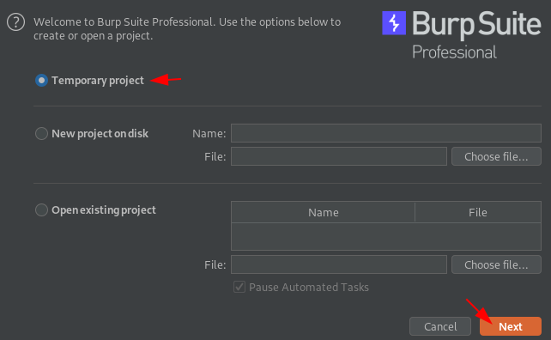

The **Next**button would lead us to the **Project options**window where we’ll opt for the **“Use Burp defaults”**and initiate with the **Start Burp**button.

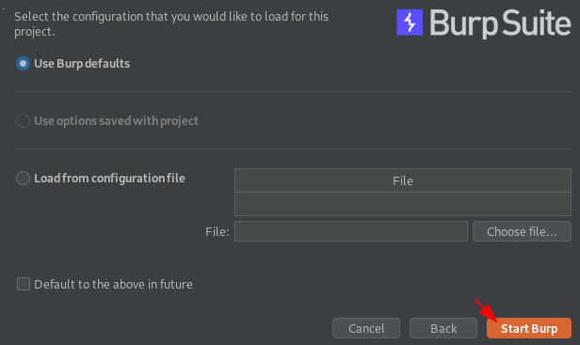

Once the key got **fired up**, we’ll be redirected to the dashboard screen with a **Temporary project** listed at the top.

In order to enhance the working speed, burp temporary project stores all its generated **data into the system’s memory,** and nothing is saved by default. Thereby whenever the burp exits, everything will be lost and we need to configure the burp again for the other projects.

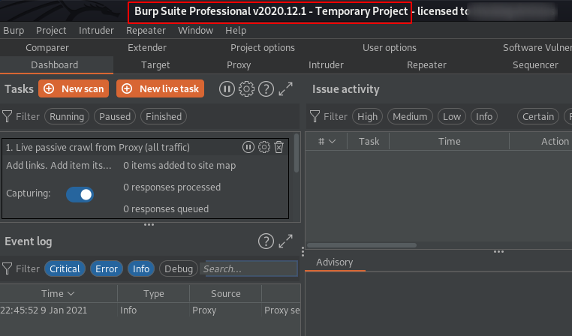

**Project on Disk**

That was the major problem that the burp users faced about their system memory usage and saving the project parts.

Thereby in order to sort things out, PortSwigger offers a great feature for its pr**ofessional edition users**, that they could **create project files on their disks.**That means the data will be shared with a project file and the contents within it will be saved incrementally on a real-time basis as we work.

However, the memory usage will be a bit lower because a lot of data has been pushed onto the disk.

So, let’s **create a project file** and will see how things work on. Back onto the **Select Project widget,**opt **“New project on disk”**and name it as **Demo_Project.**

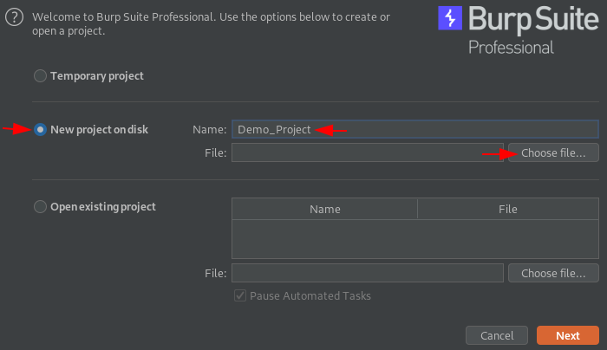

Once we hit the **“Choose file…”**button, a new window popped up asking us to add the location where the project will be saved.

So, let’s make it to the Desktop and we’ll thus hit the **Save**button.

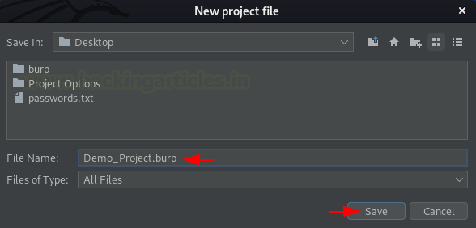

Within an eye blink, we’ll be on the **Select project**screen. Hit **“Next”,**and follow up to the next window.

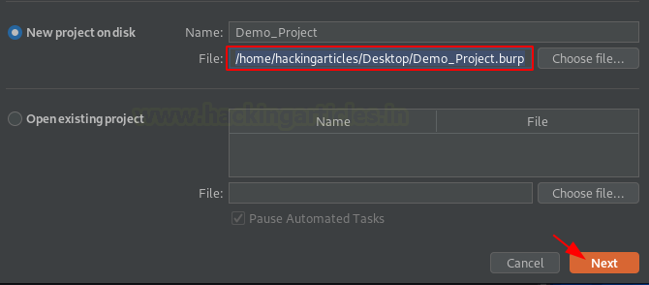

Again, we’re back on the **project options window**, let’s keep the default one. And the rest of the options we’ll discuss later in this article.

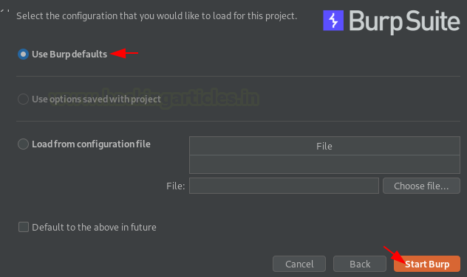

Hit **Start Burp** and let the dice rollover. Within a few seconds, the burp opens with the project name reflected at the top.

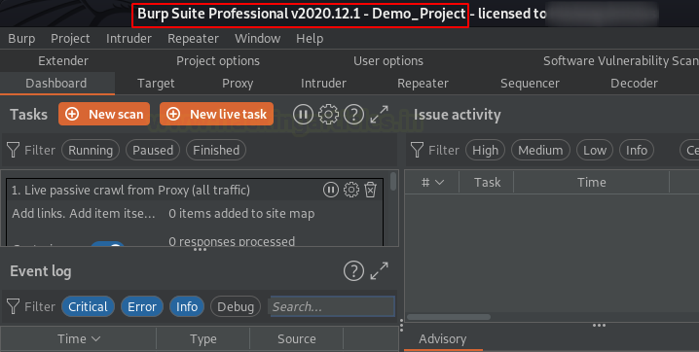

Time to generate some data, let’s capture something. **Turn ON** your browser’s proxy and surf the **OWASP Juice Shop**there.

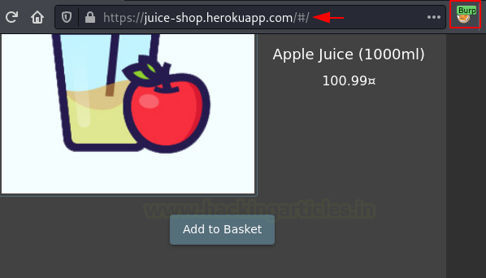

With the Intercept option **turned OFF** on our burp suite’s proxy tab, let’s switch to the **Target tab**, and there we can see the **Site map**is full of shared Requests and Responses.

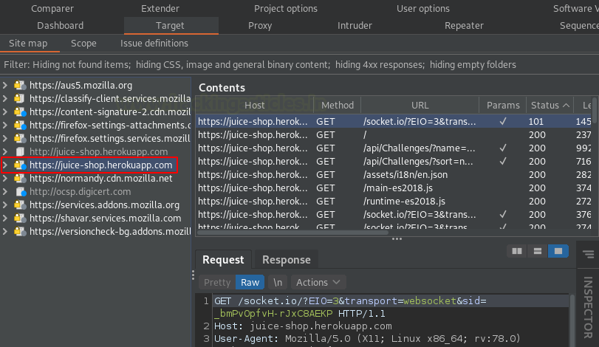

However, in **HTTP History,** a number of requests are aligned up there too.

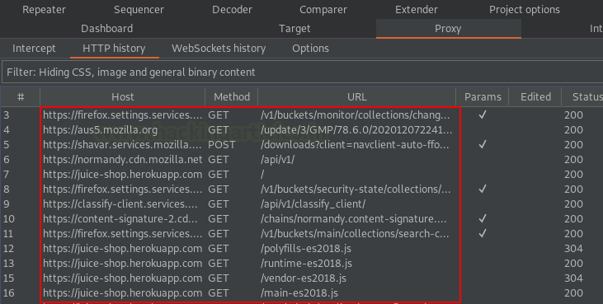

With all this, let’s **create a scan**task too with a basic crawl and audit at testphp.vulnweb vulnerable web-application. If you want to learn how to **set up a New scan**, check out our[**previous article**](https://www.hackingarticles.in/burp-suite-for-pentester-thburp-suite-for-pentester-web-scanner-crawlere-scanner-the-crawler/).

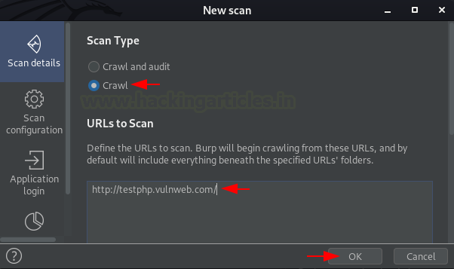

And as we hit the **OK**button, the task got lined up at our dashboard window. Within a few minutes, it crawled about **32 locations** by sharing about **150+ requests**.

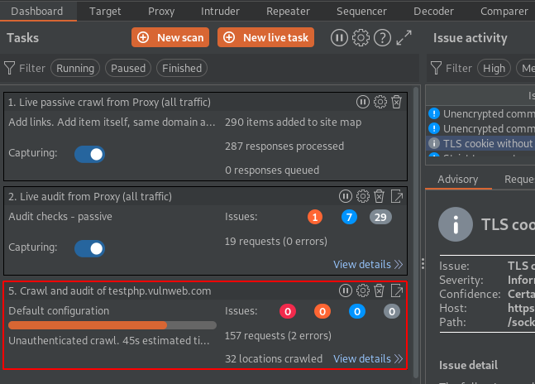

About 45 seconds left for the crawler to end its work, let’s close the burp application with the scan running on the dashboard and we’ll restart it again.

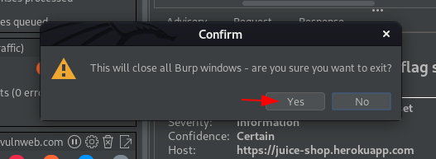

**Open Existing Project**

As the burp launches again, this time we’ll select the **“Open existing project”**at the Project section window and will further hit the **Choose file**button in order to select our project file.

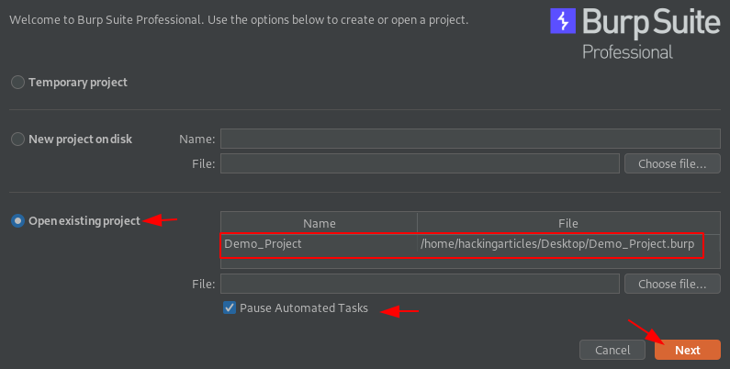

The **“Pause Automated Tasks”**was checked by default, this will pause all the automated scans there were running over in our file.

So, let’s select the **Demo_Project.burp**in the**Open project file**option and then hit the **“Open”**button in order to load the same.

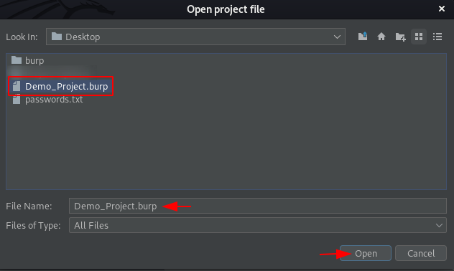

Time to load the configuration, as we’ve opened our existing project thereby the default would be **“Use options saved with the project”** as whatsoever changes or configuration we made during the project, everything got saved automatically with the project file.

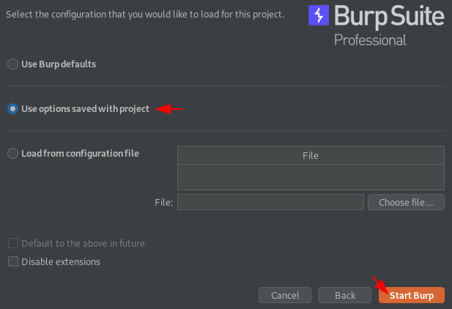

Hitting the **Start Burp**button will open our project. Let’s check that out what it carries.

From the below image, we can see that we got a pop-up as **“Task execution is paused”,**we got this due to its default behaviour that had the check box enabled for Pause Automated Tasks. And along with this, we can see that our **task is there where we’ve left off**, however, some requests and some locations have been crawled while we were exiting the burp application.

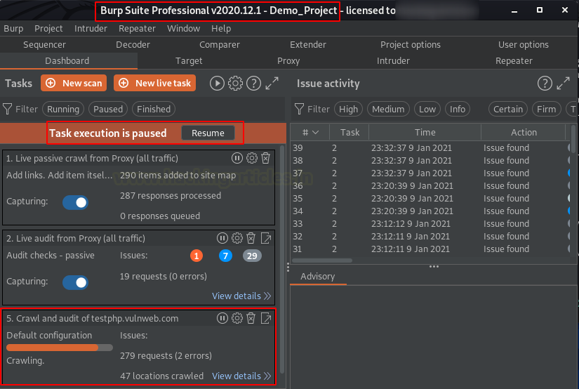

Let’s check the Site map, is it carrying the same things or not. And there it is, the crawled web-applications are there.

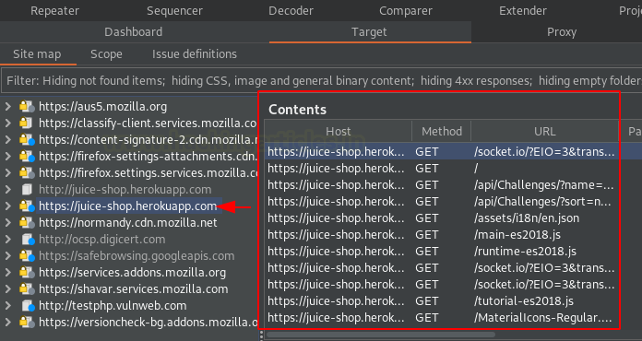

If these things are the same, then the **HTTP History** might be the same too, let’s switch to the panel there. And there the things are.

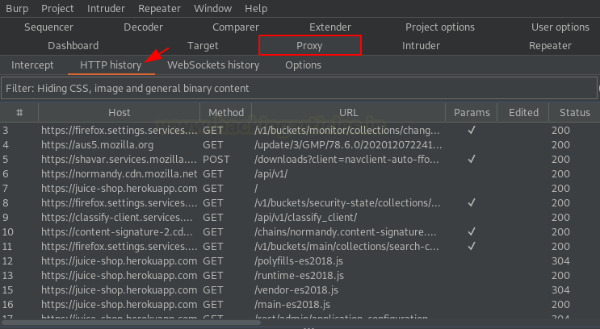

**Note :**

While working with these project options, a point made me scratch my head that what about the burp collaborator’s polling, like what if we exit the application with the **collaborator client ON**, how we’ll get to know that the vulnerability got triggered or not?

However, nothing to be worried about that, the project file saves this thing too i.e., the burp will resume the collaborator polling and will identify the vulnerabilities that were triggered at the end of the previous scanning.

### ****Manipulating Project Files****

With all these great options, the burp suite even gives us the opportunity to **Save a copy** of our running project or merge the work from other **projects by importing them** from the disk.

The **Save copy** option is for both the project types – **Project on disks and temporary projects.**But the**Import project file** feature is only for Project on disk scenarios. So, let’s check where we can find them all.

At the top of the Burp Suite’s panel, when we hover the **Project**option there, we got a dropdown where a number of options aligned, let’s hit the **Save Copy**one.

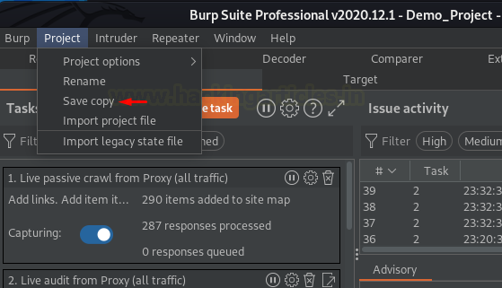

As soon as we do so, a new window will pop-up asking to **check the tools** from where the data needs to be saved. Let’ check them all and will name the new project file as **Demo_Project_Copy.**

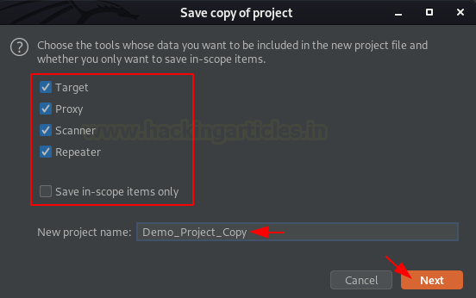

Hitting the **Next button** will redirect us to one of the most important pages i.e., **include the burp collaborator identifier** or not.  Let’s make it to default because we want the collaborator identifier to be saved with the project data and as soon as we hit the **Next button**the copy of our project will be saved.

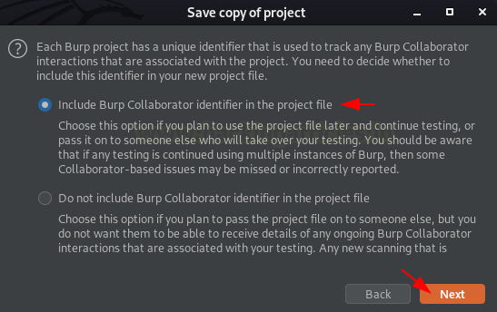

However, in a similar way, we can do it for temporary projects too.

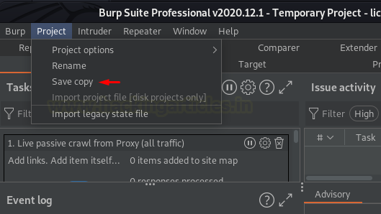

There are times when we want to merge some other project contents into our current working project, thereby we can do this by simply selecting the **“Import project”**open directly from the dropdown list.

The best part of this thing is that the importing will not affect our work and we can continue to do that.

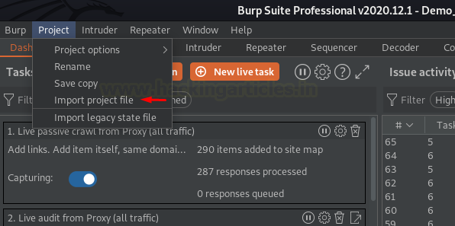

### ****Playing with Project Options****

Burp Suite offers a wide range of options that determines the behaviour and the working of all built-in tools. However, we can **customize these options, load them, or save them** at the global level with the Project tab or the options tab within the individual tool.

**Note –**

If we’re working on an **on-disk project**, all the options that we change or customize got **automatically saved** within the project data, thereby we don’t need to save the options separately. But if we’re working with the **temporary project,**we **need to save them** in order to make the changes available whenever we reload the file with some other project.

Let’s initiate and explore where the options are and how we can export them to the drive and load them within a new project.

**Exporting the customized options**

Over with a temporary project, let’s manipulate the proxy listener in the **Options section** of the **Proxy tab** by adding a one there with **all interfaces bound to port “8081”**

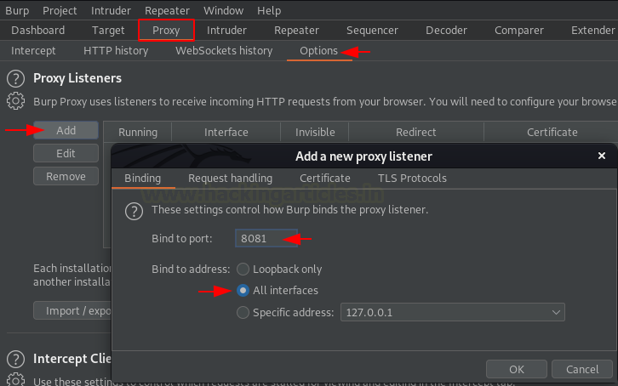

Now, further heading to the top panel, opt **“Project”** and over from the dropdown list **“Select Project options”** there, hit the **“Save project options**” in order to save all the customizations made within any of the tools.

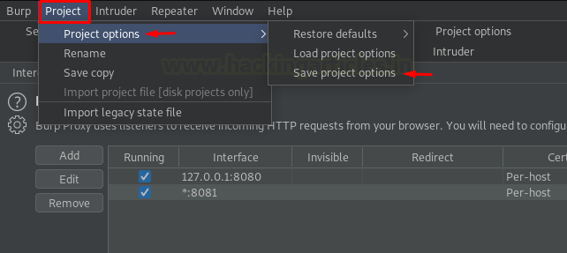

The **Save project option** will redirect to a pop-up window and there we’ll enter the configuration file name as **Interface_Options**, and will then hit the **Save button**.

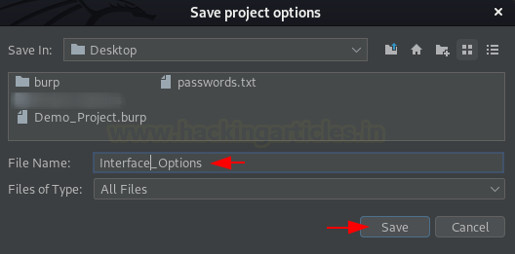

Let’s restart the burp application and this time we’ll open our **Demo_Project** again.

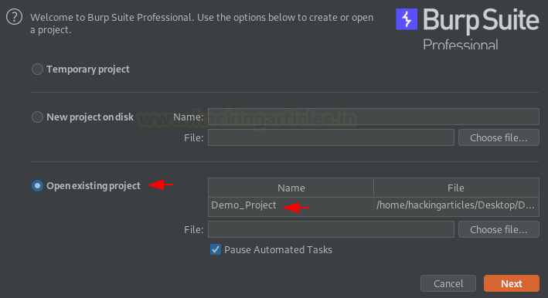

Over at the **Project Options** window, we’ll select the **“Load from configuration file”**option and will hit the Choose file button and select **Interface_Options.json** file from there.

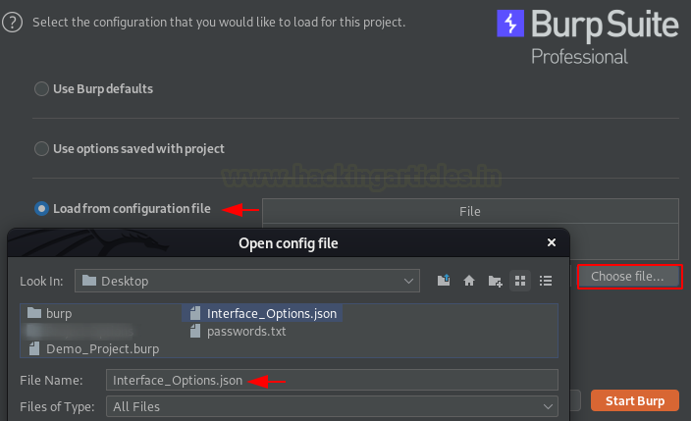

As soon as we hit the **Start Burp** button, we‘re back on the **dashboard panel**, let’s switch to the **Proxy tab**then.

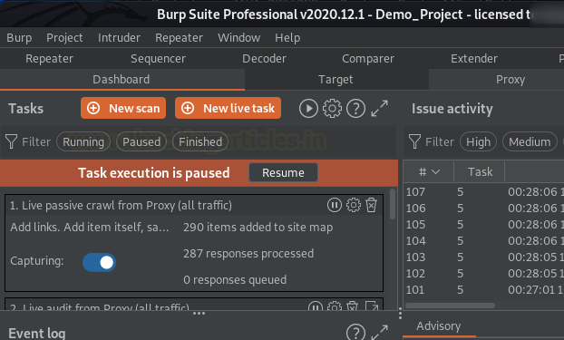

Over on the **Options section**at the**Proxy tab**, we can see that the **Interface had been configured** with the configuration file and we’re having the **port 8081 bounded**.

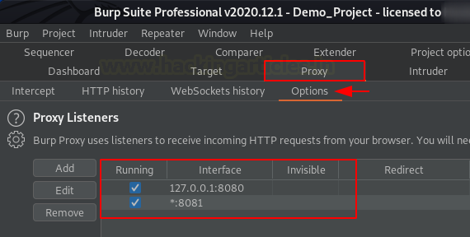

But what if we want to save or load the options of a single tool only like we did in the above scenario?

To do so, simply switch to the tools option tab and hit the **gear icon**, so for the time being let’s remove the 8081 bounded services, and then we’ll load the file again but this time we’ll do it from the Proxy tab.

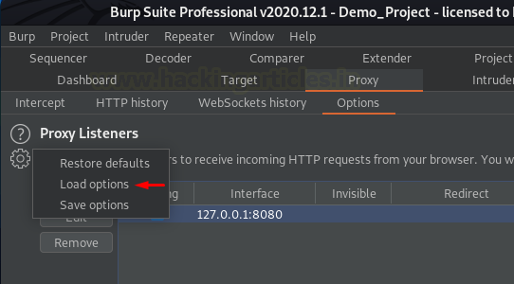

As soon as we hit the load button, we got the window to select the file, simply choose the respective one and hit the Open button there.

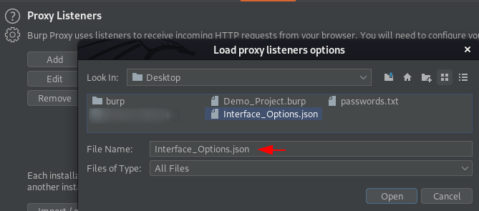

Once loaded, we’ll get all of our configurations back into the tool.

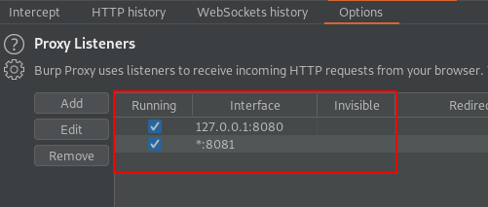

# API Scanning with Burp Suite

Sam Fernando | 11 March 2021 at 16:08 UTC

[Burp Suite](https://portswigger.net/blog/burp-suite)

Both [Burp Suite Professional](https://portswigger.net/burp/pro) and [Burp Suite Enterprise Edition](https://portswigger.net/burp/enterprise) contain [Burp Scanner](https://portswigger.net/burp/vulnerability-scanner) - allowing users to easily scan web applications for vulnerabilities. Other blog posts cover how Burp Scanner’s crawler follows links in web pages to find attack surfaces that might expose security vulnerabilities. In this post we discuss how the crawler was adapted to work with **API**endpoints rather than web pages.

Most of us use web applications frequently for everyday things like news, entertainment, shopping and so on. These web pages are intended for ordinary end-users. However the web is also used to provide APIs (Application Programming Interfaces), which allow different applications to talk to each other. There are many APIs offered by a wide range of organizations. Some of these are public APIs which are offered as a service to paying customers, but APIs are also used to provide microservices internally within an organization, allowing different teams within the company to integrate their separate modules together. These APIs provide a wide range of additional attack surfaces to malicious users, and often these are overlooked by security teams because they are only used by developers and other machines (see the [interview with Corey Ball](https://portswigger.net/blog/hack-your-apis-interview-with-corey-ball-api-security-expert) for more information on this).

### Examples of APIs

As an example consider a company such as ZapMap which is developing a website that allows users to find nearby charging points for electric cars. The company wants to show the charging points on a map. To do this they can use a mapping API (for example Google Maps API) to generate maps with the charge points marked on it. In this case there would be some initial setup steps needed, as they would need an API key to use the service. But then to obtain the map data, they would then simply send web (HTTP) requests in the same way that our web browsers do when requesting web pages. The request would contain information such as which area of the map is required, along with the locations of the charging stations. Then in response, instead of sending a normal HTML web page (which is what we see in our browsers) the Map API service would return the data required to display the map on the ZapMap web page, along with the locations as markers.

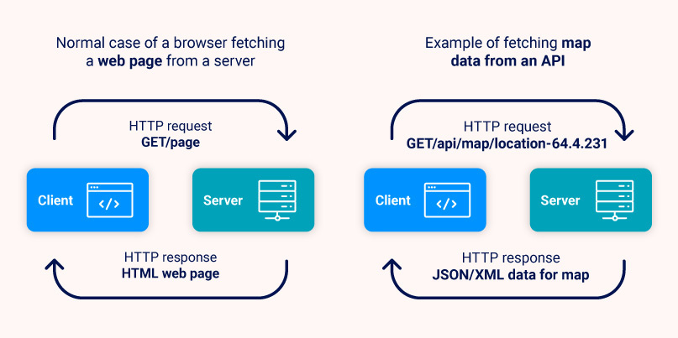

### The OpenAPI standard

APIs are usually documented so that users are aware of what capabilities are available and of what syntax is needed for the different API endpoints (the interface methods which users of the API can access). A relatively recent development is the OpenAPI standard for defining the API endpoints. This standard defines a YAML or JSON structure that is used to specify the endpoints in a standardized way, including the servers that host the API, and for each endpoint a specification of the required and optional parameters, the return type and so on. These documents are designed to be readable by both humans and machines. The fact that it is machine readable means that a developer can easily parse the OpenAPI document in their chosen programming language (e.g. Java/Python) and instantly have the interface ready to use.  
  
Here is an example of an OpenAPI specification for an endpoint:

paths:

    /users/{userId}:

       get:

         summary: Returns a user by ID.

         parameters:

             name: userId

             in: path

             required: true

             description: The user id

 schema:

                 type: integer

                 format: int64

                 minimum: 1

         responses:

             '200':

                 description: OK

The endpoint is located at /users, and has one parameter userId, which is a path parameter of type “integer”, with a minimum value of “1”. So from this specification the following requests are valid for this endpoint:

GET /users/1 HTTP/1.1

GET /users/2 HTTP/1.1

GET /users/1932899 HTTP/1.1

### Rewriting Burp Scanner to work with OpenAPI

Returning to Burp Suite and [web application security](https://portswigger.net/burp/application-security-testing), API endpoints provide additional potential attack surfaces for malicious hackers. So if we find an OpenAPI document we can automatically find the endpoints that are exposed and the crawler can add these endpoints to the list of items passed over to the scanner.  
  
In principle this sounds straightforward, but it presented a number of technical challenges during implementation.

#### A brief description of the crawler

First I’ll give a brief description of how the crawler works with normal HTML web pages. At a simple level, we consider each page as a set of links to other pages. The crawler visits each of these links in a breadth-first manner, adding each new page found as a possible attack surface for the scanner. Internally we abstract the details of different types of links by using the metaphor of a person searching through a maze. Instead of thinking about pages and links, we talk about **Rooms**and **Doorways**. We can think of a Room as roughly corresponding to a web page with a set of Doorways i.e. links to other Rooms (pages).

One advantage of using this abstraction is that we don’t get bogged down in the fine details of all the different possible HTML elements and technologies. For example, instead of a link on a page we might have a form (for example a login or registration form). These have multiple inputs that the user needs to fill before submitting to move to another page. Now we can consider forms as another kind of Doorway. So we might have an **AnchorDoorway**which represents a normal link (anchor being the term used to denote a link in HTML). Then we can have a **FormDoorway**that represents another kind of Doorway that requires multiple user inputs before moving onto another room. This has the advantage that we can then re-use all the existing algorithms for navigating through Rooms and Doorways without rewriting everything to work with forms as well as links.  
  
However forms raise complications for the crawler: what do we input into the forms? In our crawler terminology we consider the form fields as **Keys**that we need to provide to get through the Doorway. We use a number of different strategies to construct the Keys for the form Doorway, which partially depend on what the user has configured. We have the concept of **Guess Keys**, which provide a reasonable value for each field based on the name of the form field. So for an email field we will construct a fake email address, and similarly for country, phone Number and so on. Another type of Key is a **Canary Key** - this is a random string that we use and store for a specific purpose - we want to see if the Canary Key we entered appears in other Rooms (pages). This might indicate a possible vulnerability as it shows that the raw input that is entered by the user is reflected in other pages, allowing malicious users to inject malicious code into the form and have it take action elsewhere, such as in XSS attacks (see our [page on XSS attacks](https://portswigger.net/web-security/cross-site-scripting) for more info on this). And finally we have**Credentials Keys**. These are details provided by the user to allow the crawler to proceed into restricted areas of the website, for example login details.

#### Crawling OpenAPI documents

When faced with the problem of crawling the endpoints specified in OpenAPI documents, our first approach was to consider each endpoint in a similar way to an HTML form. After all, each endpoint specifies a list of required (and optional) parameters, in much the same way as an HTML form. The OpenAPI specification allows enumerations as parameters (i.e. a finite list of options), which correspond to the drop down menus or radio buttons found in HTML forms.

Although we made some initial progress with this model, we quickly ran into problems. Despite the similarities between OpenAPI specifications for endpoints and HTML forms there are important differences when it comes to the specific details.

For example HTML forms can have input checkboxes that are either checked or unchecked. If a user does not tick the checkbox then that parameter is not sent in the request when the form is submitted. However Boolean fields in OpenAPI have a different behaviour. In this case if the parameter is not supplied then a default value is supplied which is false. This can result in different behaviour from the API. There are similar differences in other data types such as number fields.

So we set to work in creating a new APIDoorway independent of our HTML form handling, allowing us to follow the OpenAPI specification without trying to fit into the old HTML form approach.

Here one of the bigger challenges we faced was that of submitting a JSON request body, which are required by some API endpoints. This was entirely new functionality for the crawler - our existing code had the facility to submit parameters in POST request bodies for HTML forms (with types application/x-www-form-urlencoded and multipart/form-data), but the ability to submit a JSON request body is a new feature. This is a powerful new feature since it opens up a lot of attack surfaces for REST API endpoints that require JSON inputs.

#### Deciding what parameters to send in the crawl

Given a particular endpoint it is quite possible to have a huge number of possible parameters that could be submitted. For example an open String parameter with no constraints could have a virtually unlimited number of possible valid inputs. So it would be impossible for the crawler to attempt to try all combinations of parameters. However, at the same time we would like the crawler to achieve good coverage by trying a reasonable number of possible parameter combinations to expose possible attack surfaces.

We have decided on the following combinations:

* Every combination of **server**(as long as it is in scope) and **path**methods (GET, POST, etc.). So if we have three servers and an endpoint with a GET and POST method, this would be 3 x 2 = 6 total endpoint locations.
* If **optional**parameters are defined, the crawler will send at least two requests to that endpoint: one request containing only the mandatory parameters and another request that includes all of the optional parameters as well.
* In the case of **enumerated**types, the crawler will send a separate request for each of the parameter's permitted values.
* In the case of **numeric**values we use the maximum and minimum values as specified.
* If **example**sets of parameters are provided we use the final provided example.

If the parameters are not defined in one of the ways listed above we revert back to using Guess and Canary Keys as we do for HTML forms.

#### Examples of crawler requests for OpenAPI specifications

This snippet shows the specification for a GET endpoint with two sets of examples for the parameters:

"paths":

{

  "/api": {

    "get": {

      "summary": "Summary of this API endpoint",

      "requestBody": {

        "required": true,

        "content": {

          "application/json": {

            "schema": {

              "type": "object",

              "properties": {

                "stringField": {

                  "type": "string"

                },

"numberField": {

                  "type": "number"

                }

              }

            },

            "examples": {

              "example1": {

                "value": {

                  "stringField": "example1",

                  "numberField": 1.5

                }

              },

              "example2": {

                "value":

                {

                  "stringField": "example2",

                  "numberField": 2.5

                }

              }

In this case the crawler would use the final example, i.e. “example2”, to send the following request (omitting some of the HTTP headers):

GET /scans HTTP/1.1

{"stringField":"example2","numberField":2.5}

Another example with enums:

"paths": {

  "/stringParameter/{stringParameter}":{

    "get": {

      "summary": "Summary of this API endpoint",

      "tags": [

        "scans"

      ],

      "parameters": [

        {

          "name": "stringParameter",

          "in": "path",

          "required": true,

          "schema": {

            "type": "string",

            "enum": [

              "enum1",

              "enum2"

            ]

          }

        }

      ]

   }

}

In this case the Crawler would send the following requests, using both enumerations of the string parameter and the minimum and maximum values for the number parameter:

GET /stringParameter/enum1 HTTP/1.1

GET /stringParameter/enum2 HTTP/1.1

These endpoints would then be sent to the scanner as destinations to scan.

### Conclusion

We've introduced the API scanning feature as a foundation to cover this growing area of demand. We have a lot of new ideas in the pipeline - the first of which you can see in our latest [roadmap](https://portswigger.net/blog/burp-suite-roadmap-for-2021). You can also find a[summary of the API scanning feature here](https://portswigger.net/burp/vulnerability-scanner/api-security-testing).